**Table of Contents – ZCCA Course**

1. Create a Sales Management App

2. Create a Form Product Year using **From Scratch**

3. Access and Explore the Application

4. Create a Product Make Form using **Import File**

5. Link the Product Year and Product MakeForm

6. Configure Access to App

7. Create the required Forms for the Application by Importing data

a. Create a Form Product Model – Use Filter in Lookup

b. Create Material Type Form

c. Create Material Names Form

d. Create Location Form

e. Create Location Pin code Form

8. Create Materials Inventory Form – Use Filter in Lookup

9. Create an Order Form using **From Template**

10. Create a Customer Inquiry Form

11. Create Place Order Form with Subform

12. Date Validation

13. Fetch Product price and Availability

14. Calculate the Final Price for each product and required quantity

15. Place the Final Price calculation in OnUserInput action wherever required

16. Check Availability of Stocks

17. Create a Form Minimum Stock

18. Automate your place order form

a. Send Mail when Availability reaches the minimum stock level

19. Create a Form Warehouse Management

20. Insert records and maintain a Warehouse Management report

21. Insert customer records and maintain a Customer data

a. Bidirectional Lookup

22. Determine the To be Delivered report

23. Function and Create Confirm & Reject button

24. Customize the App Look & Feel

25. Schedules

26. Create calendar report for Place Order

**Lesson 1: Create a Sales Management App**

**Scenario**

You want to automate your Automobile parts sales business process with an app that tracks availability and allows customers to order a part. To get the most flexibility, you will create an app from scratch. The app must have a Place Order to order parts and Materials Inventory form to match existing part type available in spread sheet.

1. Login into your Creator account, and click on **Create Application** option on the top right corner of your homepage.

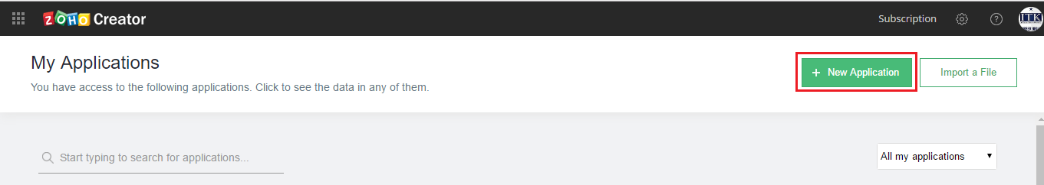

2. There are three options to create an application: You can either use the **Application gallery** to install a ready-made app and tweak it a bit to suit your requirements (or) use the **Import File** option to create an app by importing data from your local file or from the cloud (or) use the **From Scratch** option to create an app from scratch. In this tutorial, we will choose from the **From Scratch** option to create our Sales Management app.

3. Select **From Scratch,** enter the Application name as **One Stop Auto Shop Online** and click on **Create**.

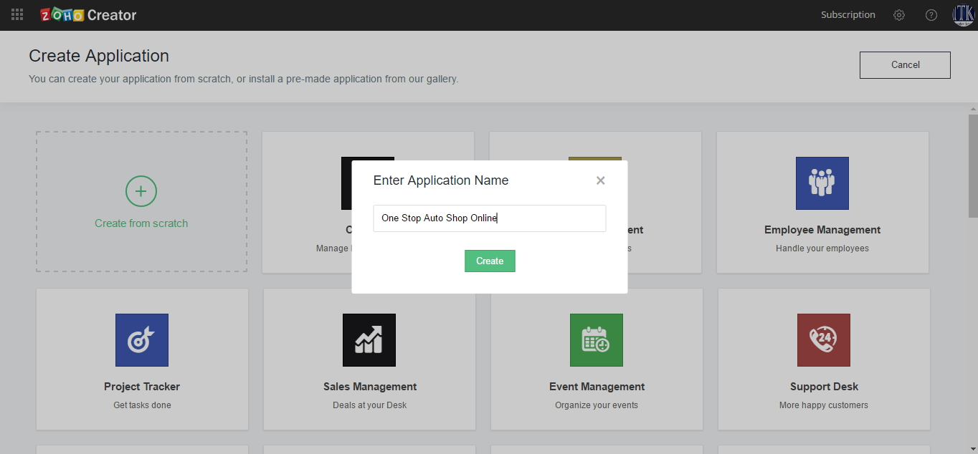

**Lesson 2:** Create a Form **Product Year** using **From Scratch**

**Scenario**

One of the requirements in our Sales management app is to enable the customers to select the Product Year of their Spare parts. So, let us start with creating the Product Year Form. This Form will be used to manage Orders placed by customers.

1. In Form Properties, enter Form Name as **Product Year**. Now, add the following Fields to the Form.

* + - Add Year Field to select the Product Year by the Customer who place the order
      * From the Fields List, drag and drop a **Single Line** field to the top of the Rooms Form.
      * On the right side of form editor, on the **Field Properties** Configuration object, for Field Name **Year**.
      * In the Validation configuration box, check the **Mandatory** check-box.

2. Verify that the Form looks like the following image.

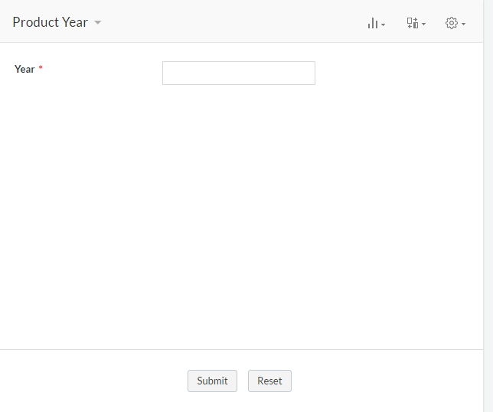

**Lesson 3: Access and Explore the App**

**Scenario**

Now the **One Stop Auto Shop Online** app is created with the Year Form, let us see how the application looks in live mode.

1. Familiarize yourself with the App Interface

a. Verify that you are in the live mode of the application with the **Year** Form displayed.

b. Click on **Go To – Home** on the top right corner of the app. Notice that **One Stop Auto Shop Online** app is listed in your homepage.

c. On the Zoho creator Home page, select **One Stop Auto Shop Online** app, to launch it.

d. On the upper right portion of the page, notice the Zoho Creator quick links

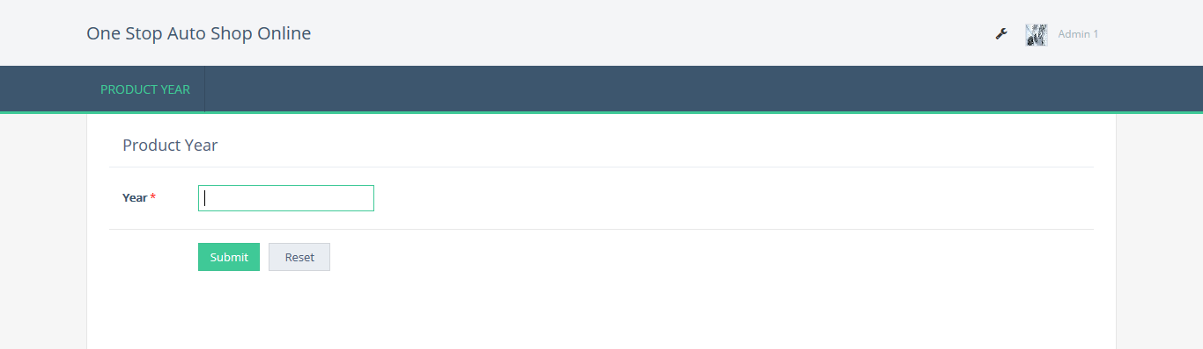

2. Submit a Year

a. Fill in the **Product** **Year** Form with sample entries.

b. Under the **Product** **Year** menu, notice that there is a **Product Year Report** link displayed along with the **Product** **Year** Form. This is the **Report** that stores all the data submitted through the **Product** **Year** Form. The data can be viewed in different formats like list, summary, and spreadsheet.

c. Click on **Product** **Year Report** to view the sample record submitted.

3. Modify the data

a. To view records in different formats, click on the settings icon on the top right corner and go to View as. Now select the format you wish to apply.

b. From **Reports** section, you can also add records.

c. Click on **Add** and create a new record

d. On hover of the existing record, **Edit** menu will be displayed.

e. Click on **Edit/Delete** to edit or delete a record.

-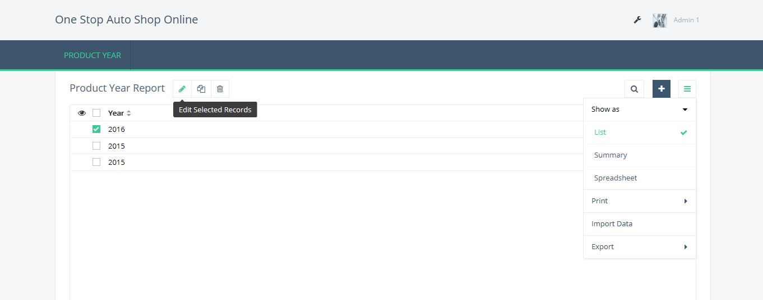

**Note**

Note that while Ordering item using through the **Product** **Year** form, you enter the Year manually each time to order a part. This results in duplication of data and possible errors from re-entering the data. In the later sections, we will replace the **Product** **Year** Field with a **Lookup** field which will display the Years as a list of values from which the user can choose.

**Lesson 4:** Create a **Product Make** Form using **Import File**

**Scenario**

The Sales Management stores all its Product Make details in an .xls file. We will now import this Product Make data into One Stop Auto Shop Online app. To import the Product Make data to the app,

1. Click on **Create New – Form**

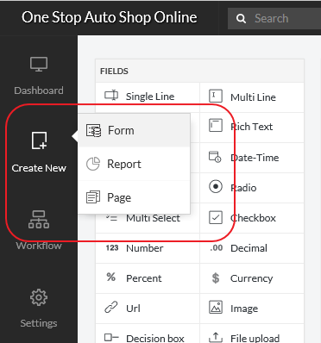

2. Select the **Import File** icon from the New Form page.

3. Download the sample Product Make file from the below link:

https://goo.gl/LqJF86

4. Browse and select the downloaded Product Make.xlsx file which holds the Product Make data and click on **Attach**

5. Click on **Create** to create an form from the input file.

6. The “importing data” dialog will display the data from the excel file. Zoho creator automatically defines the field type based on the type of data stored in each column of the spreadsheet. To change the Field type for a column, select appropriate type from the drop-down list. For example, the data type for **Type** is displayed as **Single Line**.

To view the List of Product Year available and choose the required Product Year from the list, we will change the field type from **Single Line** to **Drop-down**.

The data in the first row will be displayed as the default **Label Name** for each column. If the options **consider first row as Label Names** is unchecked, the Label Name will be left blank. You can type a new names in the Label Name box or modify the displayed names.

7. Click **Finish** to create the form with the Product Make data. The form is created and you land on Product Make Form Page. Notice that Zoho Creator automatically creates the Form and all the label names in the spreadsheet has become the Form Field names. New Product Make data will be updated through this Form

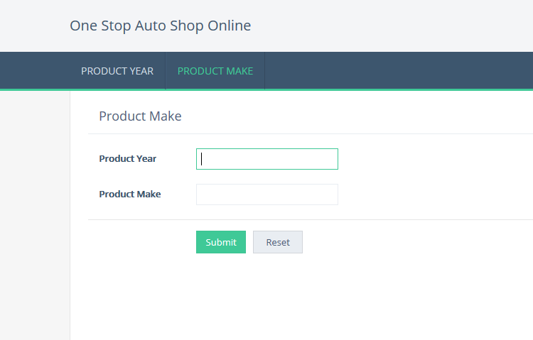

8. The data in the spreadsheet is updated in the Product Make report. Click on Product Make Report to view the Product Make data uploaded from the spreadsheet.

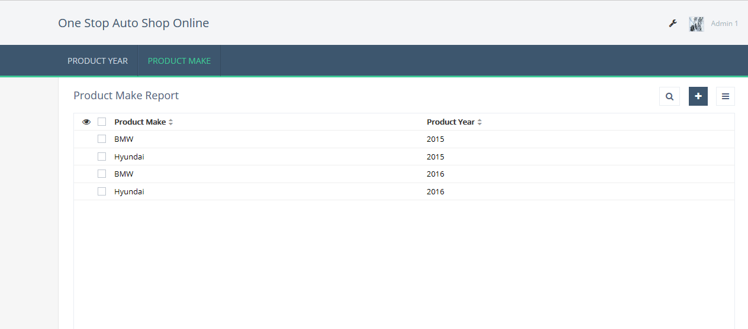

**Lesson 5: Link the Product Year and Product Make Form**

**Scenario**

The **Product Make** data is imported to the Sales Management app – **Product Make** Form. We will now replace the Product Year field in **Product Make** Form with a Lookup Field that will automatically display all the Product Year as a list, from the Product Year Form. A lookup field relates two Forms and displays a drop-down menu displaying item from the Source Form. Let us create a **lookup field** in the **Product Make** Form to relate it with the Product Year Form. This allows the Product Year data imported in the Product Year Form to show up in the **Product Make** Form.

1. Create Lookup Relation

a. Open the Form builder and drag-and-drop the **lookup field** on the **Product Make** Form.

b. A pop up appears that needs you to choose the **Applications – Forms – Fields** to which you want the Room Bookings Form to relate to.

c. Select **Product Year - Year.**

d. Select the Display type as **Drop-down** so that only one product type can be selected from the list.

e. Click on **Done** to save the changes.

f. Specify the Field name as **Product Year**. The **Product Year** Form is now linked with the **Product Make** Form through the Product Year field.

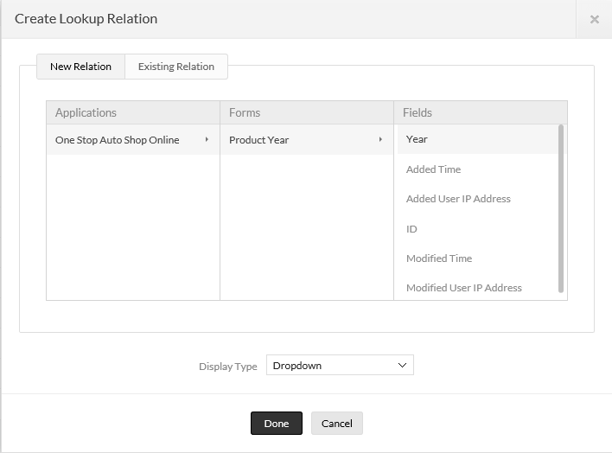

2. Access the App

a. Click on **Access this application** on the top right corner. You will be redirected to the live mode of this application.

b. In the live mode, you can see the two Forms created by you. Each Form is present under the header of the Form name.

c. Fill in the **Room Bookings** with sample entries. You will notice the Room Types displayed from the Rooms Form. This is how relationship between two Forms is achieved.

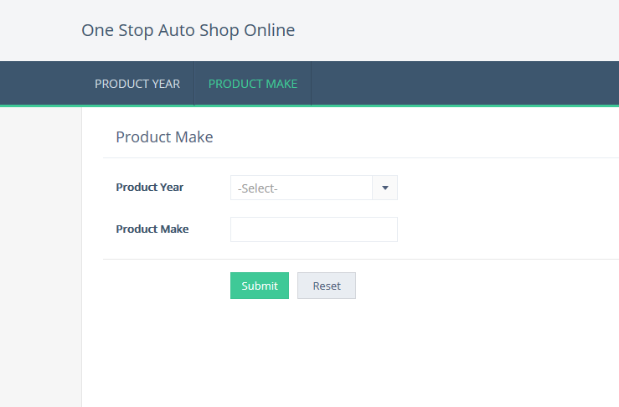

**Lesson 6: Configure Access to App**

**Scenario**

Now you need to share the Sales Management App and test user access. First share the app with the staff dealing with Rooms. The staff should be able to see the **Product Year** Form and Report, but not delete records from the report. Test access by seeing which Forms and Reports are visible, by trying to edit the app, and by trying to delete rooms data records.

a. In the Sales Management application’s edit mode, under **Application Settings** select **Share**. The Invite page appears.

b. On the Invite page, review the **1. Select Components** box. This box contains all the Forms and Reports that are part of the app.

c. At the top of the **1. Select Components** box, check the **Product Year** check-box. Sharing at this level makes everything contained within the component visible to the users it is shared with.

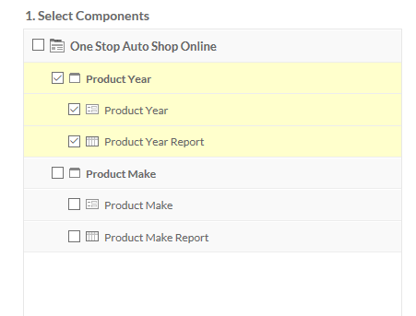

d. Review the **2. Share with users** box on the right side of the page. You can share applications with users you’ve added to Zoho Creator or Groups you’ve created.

e. Next to **Users**: select **Select Users**. A List dialog box appears.

f. Review the List dialog box. Notice that the list dialog box has a Search box that searching for users. Below the list of user names, notice the alphabet buttons that allow you to display sections of longer lists. At the bottom, left of the List dialog box notice the Select All check-box.

g. In the List dialog box, in the list of user names, check the corresponding check-box, and select Add.

h. At the bottom of the **2. Share with Users** box, verify that **Send Invitation** is checked. Notice next to the Send Invitation check-box, you have the option to **Edit Email Content**.

i. Below the **2. Share with users** box, select **Share Now**. A dialog box appears stating Sharing done with selected users.

j. Select **OK**.

**Test Access to the App**

a. Sign out of your Zoho Creator account. You are now logged out of Zoho Creator page appears.

b. Select Login, The Sign into your Zoho Creator account page appears.

c. On the sign into you Zoho Creator account page, type the email address and password of the user with whom the app is shared, and select Sign In.

d. Verify that you see the Hotel Management app on the app list, and that it is listed under **Shared Apps**.

e. Open the Sales Management app.

f. Verify that you can only access the Product Year Tab.

g. Select Product Year Tab.

h. Click Product Year Report. Notice that you will be able to view all the records in the Product Year report.

**Publish the Form**

Zoho Creator lets you publish Forms and Reports just by pasting a URL or the iframe code in your website, wiki, or blogs. The published URL will be a pubic URL and can be accessed by any user who has access to the location where the form/report is published. You can also customize the look and feel of the form or report to match your website. Let us now publish the Product Make Form to enable customers to order the product from the Sales Management website.

a. From the **Dashboard** page, select the **Forms** Tab. The list of all the Forms created in the application will be displayed.

b. Click on the **Publish** link displayed for the **Product Make** Form.

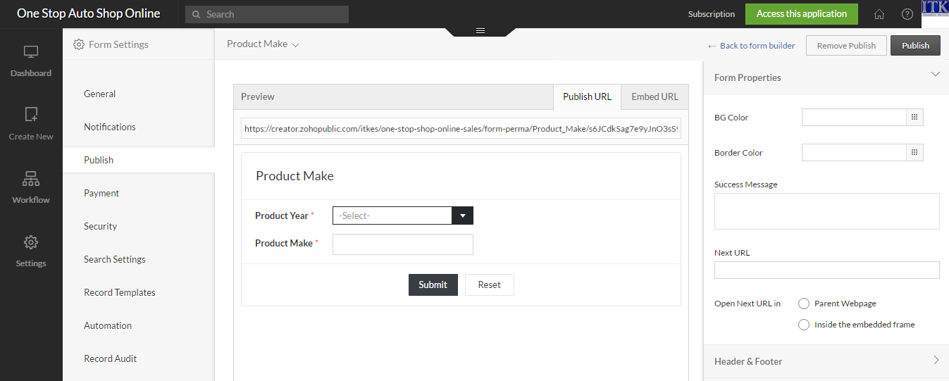

c. The Publish page will display a preview of the Form or Report to be published and the customization options. You can customize the look and feel of the published form or report to match your website

d. Click on Publish button displayed on the top-right corner of the page, to generate the publish URL and embed URL of the form or report. The published URL will be a public URL and can be accessed by any user who has access to the location where the form/report is published.

**Lesson 7** : **Create the required forms for the Application by Importing Data**

**A.Create a Form Product Model - Use Filter in Lookup**

**Scenario**

The Sales Management stores all its Product Model details in an .xls file. We will now import this Product Model data into One Stop Auto Shop Online app. To import the Product Model data to the app,

1.Click on **Create New -- Form.**

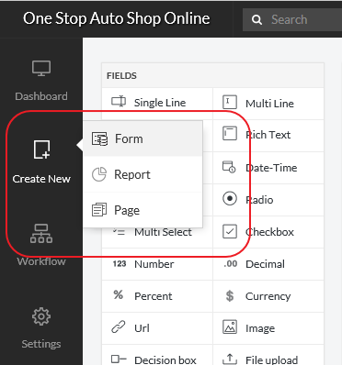

2. Select the **Import File** icon from the New Form page.

3. Download the sample Product Model file from the below link:

https://goo.gl/LqJF86

4. Browse and select the downloaded Product Model .xls file which holds the Product Model data and click on **Attach**

5. Click on **Create** to create an form from the input file.

6. The “importing data” dialog will display the data from the excel file. Zoho creator automatically defines the field type based on the type of data stored in each column of the spreadsheet.To change the Field type for a column, select appropriate type from the drop-down list. For example, the data type for **Type** is displayed as **Single Line**. To view the List of Product Year available and choose the required Product year from the list, we will change the field type from **Single Line** to **Drop-down**.

The data in the first row will be displayed as the default **Label Name** for each column. If the options **consider first row as Label Names** is unchecked, the Label Name will be left blank. You can type a new names in the Label Name box or modify the displayed names.

7. Click **Finish** to create the form with the Product Model data. The form is created and you land on Product Model Form Page. Notice that Zoho Creator automatically creates the Form and all the label names in the spreadsheet has become the Form Field names. New Product Model data will be updated through this Form

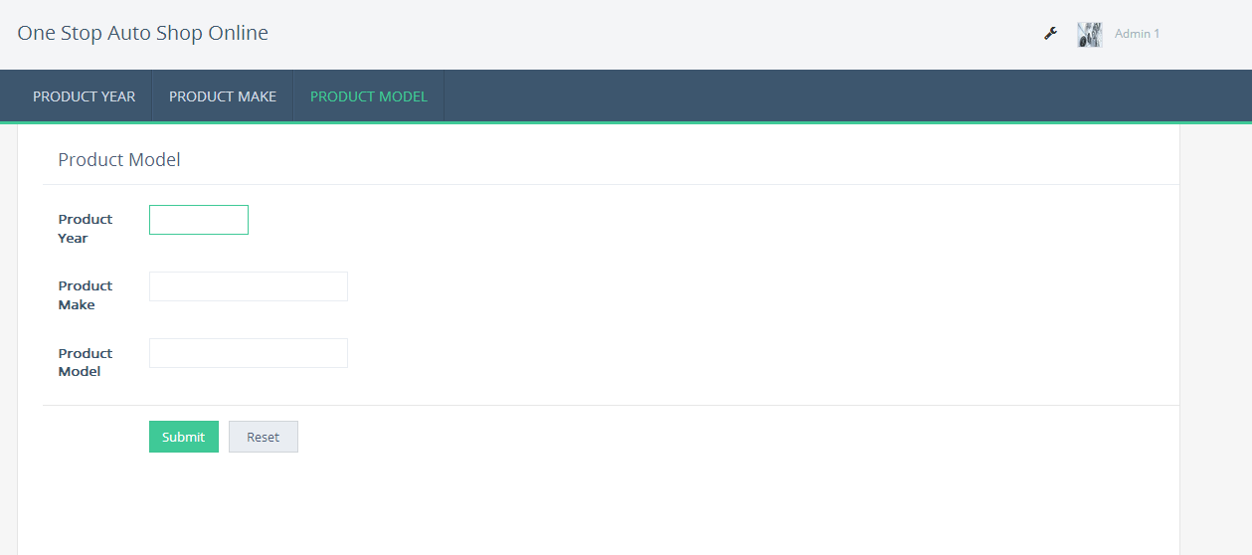

8. The data in the spreadsheet is updated in the Product Model report. Click on Product Model Report to view the Product Model data uploaded from the spreadsheet.

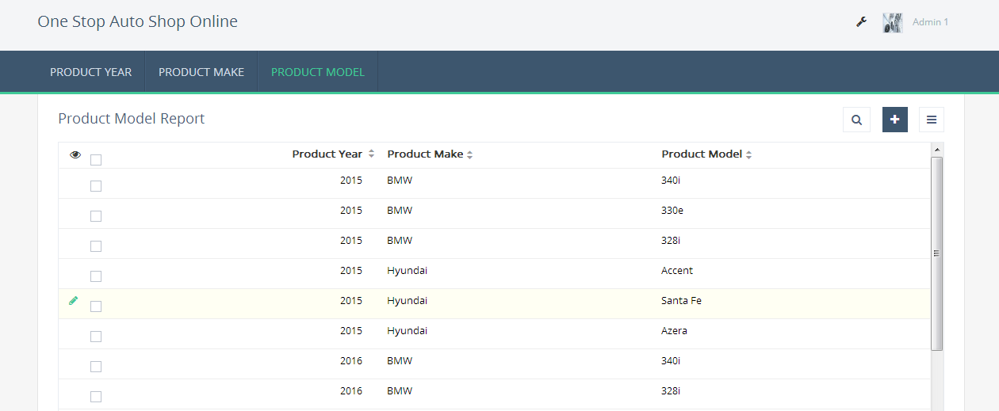

**Link the Product Year and Product Make Form**

**Scenario**

The **Product Model** data is imported to the Sales Management app – **Product Model** Form. We will now replace the Product Year and Product Make field in **Product Model** Form with a Lookup Field that will automatically display all the Product Year and Product Make as a list, from the Product Year Form and Product Make Form. A lookup field relates two Forms and displays a drop-down menu displaying item from the Source Form. Let us create a **lookup field** in the **Product Model** Form to relate it with the Product Year Form and Product Make Form. This allows the Product Year and Product Make data imported in the Product Year Form and Product Make Form to show up in the **Product Model** Form.

1. Create Lookup Relation

a. Open the Form builder and drag-and-drop the **lookup field** on the **Product Model** Form.

b. A pop up appears that needs you to choose the **Applications – Forms – Fields** to which you want the Product Year Form to relate to.

c. Select **Product Year - Year.**

d. Select the Display type as **Drop-down** so that only one product type can be selected from the list.

e. Click on **Done** to save the changes.

f. Specify the Field name as **Product Year**. The **Product Year** Form is now linked with the **Product Make** Form through the Product Year field.

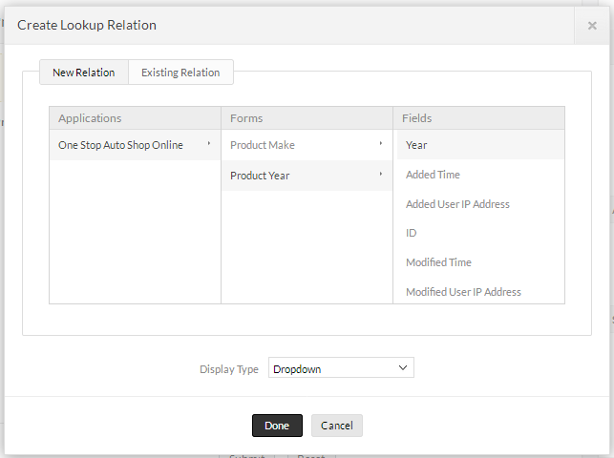

2. Create Lookup Relation

a. Open the Form builder and drag-and-drop the **lookup field** on the **Product Model** Form.

b. A pop up appears that needs you to choose the **Applications – Forms – Fields** to which you want the **Product Make** Form to relate to.

c. Select **Product Make - Make.**

d. Select the Display type as **Drop-down** so that only one product type can be selected from the list.

e. Click on **Done** to save the changes.

f. Specify the Field name as **Product Make**. The **Product Make** Form is now linked with the **Product Model** Form through the Product Make field.

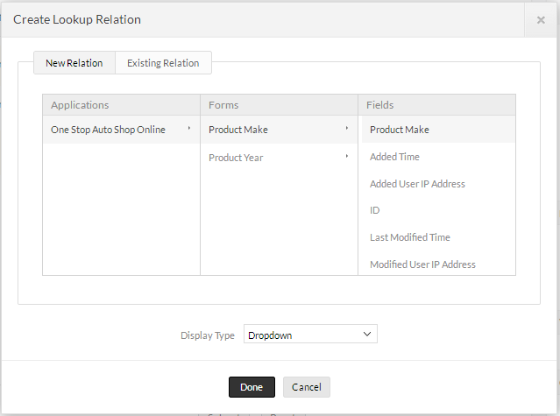

3. Access the App

a. Click on **Access this application** on the top right corner. You will be redirected to the live mode of this application.

b. In the live mode, you can see the two Forms created by you.Each Form is present under the header of the Form name.

c. Fill in the **Product Model** with sample entries. You will notice the Product Year and Product Make displayed from the Product Year Form and Product Make Form. This is how relationship between two Forms is achieved.

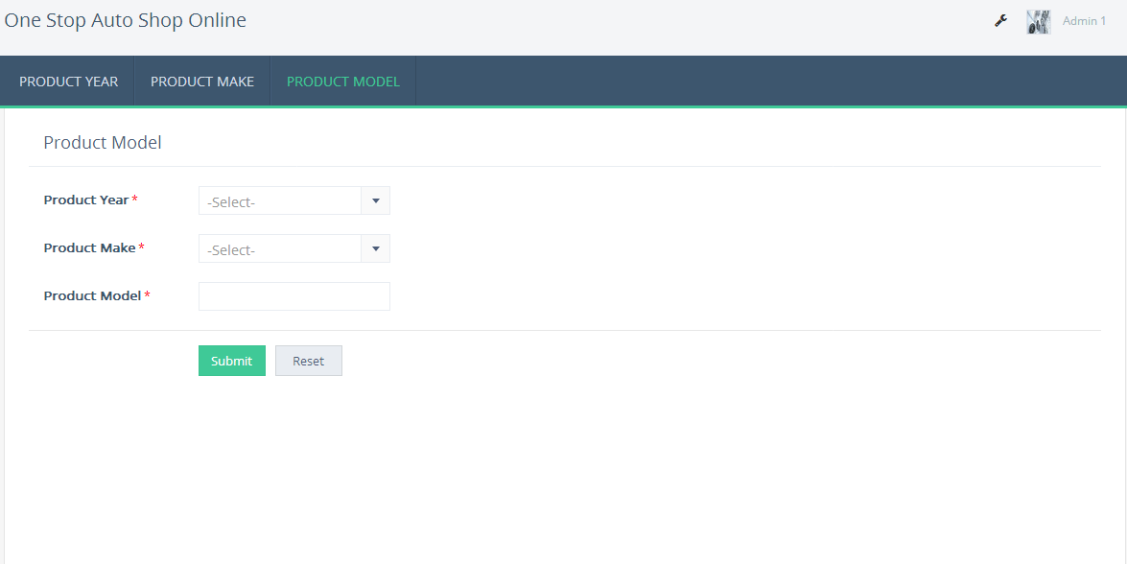

**B. Create Material Type Form**

**Scenario**

The Sales Management stores all its Material Type details in an .xls file. We will now import this Product Make data into One Stop Auto Shop Online app. To import the Material Type data to the app,

1. Click on **Create New – Form**



2. Select the **Import File** icon from the New Form page.

3. Download the sample Material Type file from the below link:

https://goo.gl/7PPhK5

4. Browse and select the downloaded Material Type .xls file which holds the Material Type data and click on **Attach**

5. Click on **Create** to create an form from the input file.

6. The “importing data” dialog will display the data from the excel file. Zoho creator automatically defines the field type based on the type of data stored in each column of the spreadsheet.To change the Field type for a column, select appropriate type from the drop-down list. For example, the data type for **Type** is displayed as **Single Line**. To view the List of Product Year available and choose the required Product Year from the list, we will change the field type from **Single Line** to **Drop-down**.

The data in the first row will be displayed as the default **Label Name** for each column. If theoptions **consider first row as Label Names** is unchecked, the Label Name will be left blank. You can type a new names in the Label Name box or modify the displayed names.

7. Click **Finish** to create the form with the Material Type data. The form is created and you land on Material Type Form Page. Notice that Zoho Creator automatically creates the Form and all the label names in the spreadsheet has become the Form Field names. New Material Type data will be updated through this Form

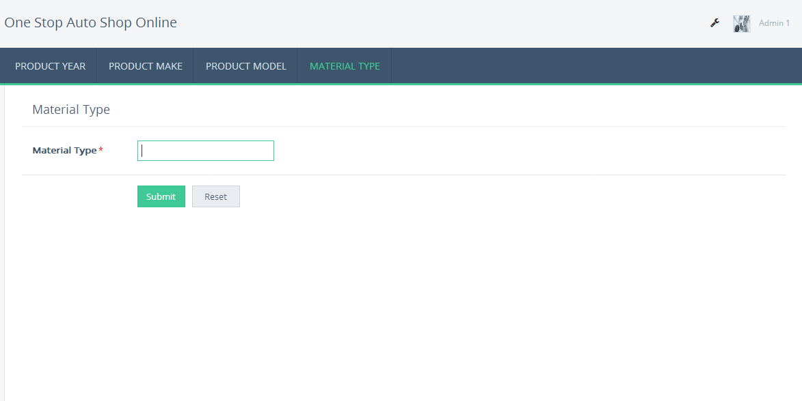

8. The data in the spreadsheet is updated in the Material Type report. Click on Material Type Report to view the Material Type data uploaded from the spreadsheet.

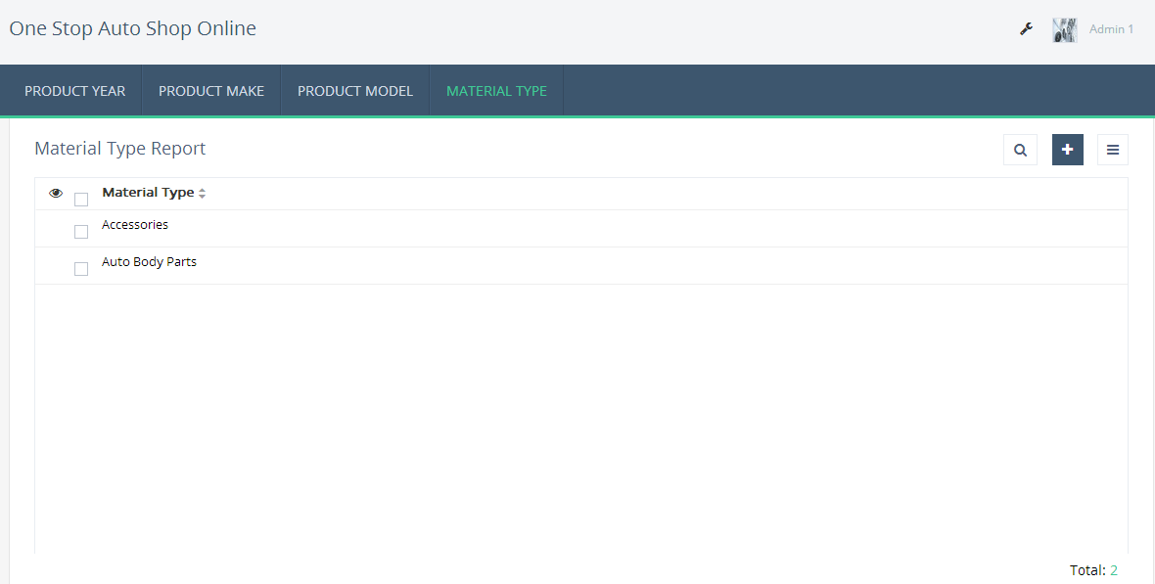

2. Access the App

a. Click on **Access this application** on the top right corner. You will be redirected to the live mode of this application.

b. In the live mode, you can see the two Forms created by you.Each Form is present under the header of the Form name.

c. Fill in the **Material Type** with sample entries. You will notice the Material type displayed from the Materiel Form.

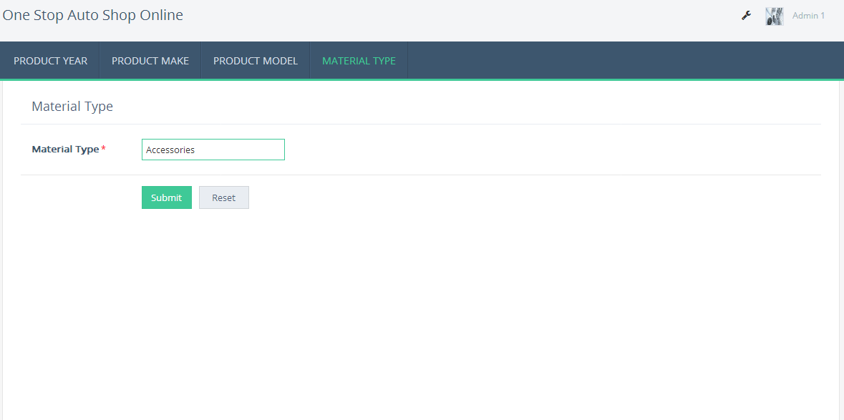

**C. Create a Material Name Form**

**Scenario**

The Sales Management stores all its Material Name details in an .xls file. We will now import this Product Make data into One Stop Auto Shop Online app. To import the Material Name data to the app,

1. Click on **Create New – Form**



2. Select the **Import File** icon from the New Form page.

3. Download the sample Material Name file from the below link:

https://goo.gl/LqJF86

4. Browse and select the downloaded Material Name .xls file which holds the Material Name data and click on **Attach**

5. Click on **Create** to create an form from the input file.

6. The “importing data” dialog will display the data from the excel file. Zoho creator automatically defines the field type based on the type of data stored in each column of the spreadsheet. To change the Field type for a column, select appropriate type from the drop-down list. For example, the data type for **Type** is displayed as **Single Line**. To view the List of Product Year available and choose the required Product Year from the list, we will change the field type from **Single Line** to **Drop-down**.

The data in the first row will be displayed as the default **Label Name** for each column. If the options **consider first row as Label Names** is unchecked, the Label Name will be left blank. You can type a new names in the Label Name box or modify the displayed names.

7. Click **Finish** to create the form with the Material Name data. The form is created and you land on Material Name Form Page. Notice that Zoho Creator automatically creates the Form and all the label names in the spreadsheet has become the Form Field names. New Material Name data will be updated through this Form

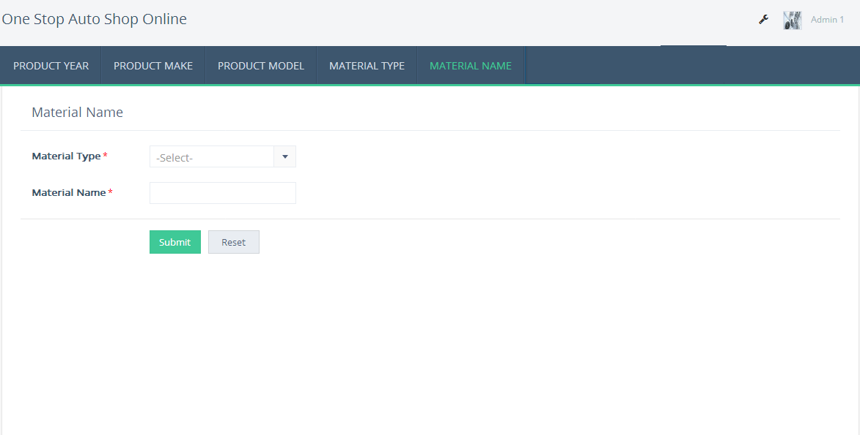

8. The data in the spreadsheet is updated in the Material Name report. Click on Material Name Report to view the Material Name data uploaded from the spreadsheet.

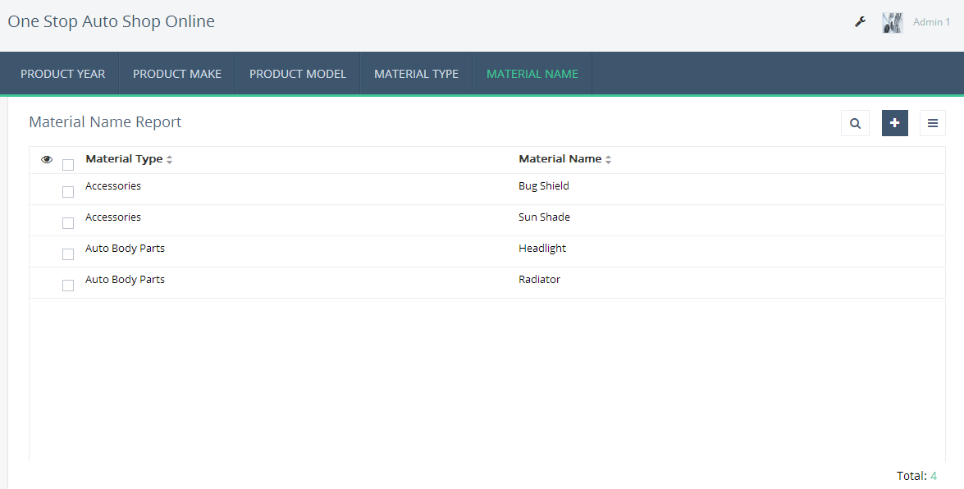

**Link the Material Name and Material Type Form**

**Scenario**

The **Material Name** data is imported to the Sales Management app – **Material Name** Form. We will now replace the Material Type and Material Name field in **Material Name** Form with a Lookup Field that will automatically display all the Material Type as a list, from the Material Type Form. A lookup field relates two Forms and displays a drop-down menu displaying item from the Source Form. Let us create a **lookup field** in the **Material Name** Form to relate it with the Material Type Form. This allows the Material Type imported in the Material Name Form.

1. Create Lookup Relation

a. Open the Form builder and drag-and-drop the **lookup field** on the Material TypeForm.

b. A pop up appears that needs you to choose the **Applications – Forms – Fields** to which you want the Material Type Form to relate to.

c. Select **Material Type - Material Type.**

d. Select the Display type as **Drop-down** so that only one product type can be selected from the list.

e. Click on **Done** to save the changes.

f. Specify the Field name as **Material Type**. The **Material Name** Form is now linked with the **Material Type** Form through the Material Type field.

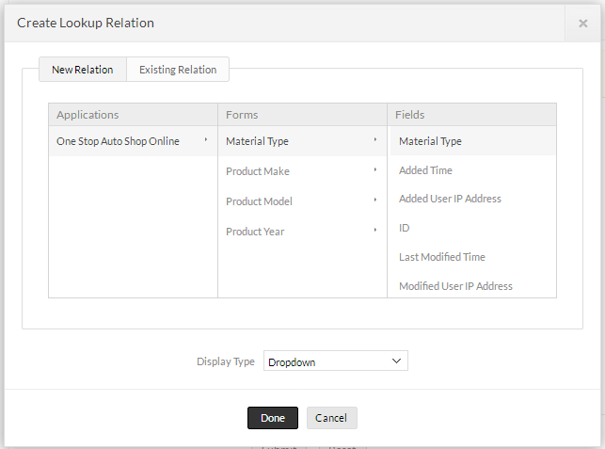

3. Access the App

a. Click on **Access this application** on the top right corner. You will be redirected to the livemode of this application.

b. In the live mode, you can see the two Forms created by you.Each Form is present under the header of the Form name.

c. Fill in the **Material Name** with sample entries. You will notice the Material Type displayed from the Material Type Form. This is how relationship between two Forms is achieved.



**D. Create a Location Form:**

**Scenario**

The Sales Management stores all its Location details in an .xls file. We will now import this Location data into One Stop Auto Shop Online app. To import the Location data to the app,

1. Click on **Create New – Form**



2. Select the **Import File** icon from the New Form page.

3. Download the sample Location file from the below link:

https://goo.gl/LqJF86

4. Browse and select the downloaded Location .xls file which holds the Location data and click on **Attach**

5. Click on **Create** to create an form from the input file.

6. The “importing data” dialog will display the data from the excel file. Zoho creator automatically defines the field type based on the type of data stored in each column of the spreadsheet.To change the Field type for a column, select appropriate type from the drop-down list. For example, the data type for **Type** is displayed as **Single Line**. To view the List of Product Year available and choose the required Product Year from the list, we will change the field type from **Single Line** to **Drop-down**.

The data in the first row will be displayed as the default **Label Name** for each column. If the options **consider first row as Label Names** is unchecked, the Label Name will be left blank. You can type a new names in the Label Name box or modify the displayed names.

7. Click **Finish** to create the form with the Location data. The form is created and you land on Location Form Page. Notice that Zoho Creator automatically creates the Form and all the label names in the spreadsheet has become the Form Field names. New location data will be updated through this Form

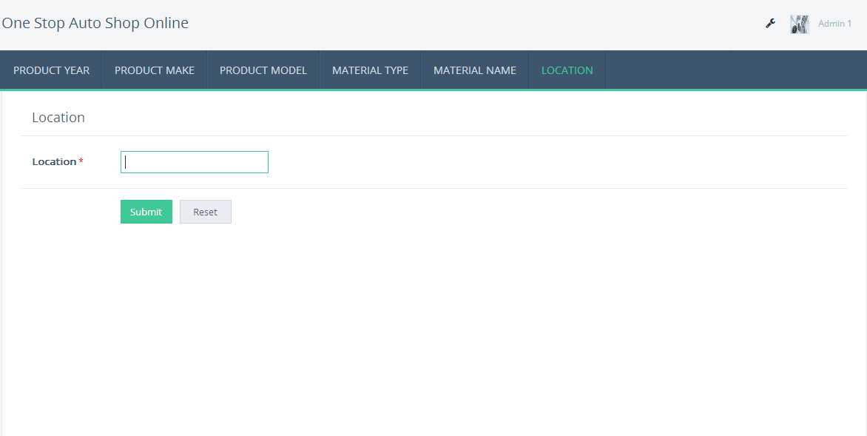

8. The data in the spreadsheet is updated in the Location report. Click on Location Report to view the Location data uploaded from the spread sheet.

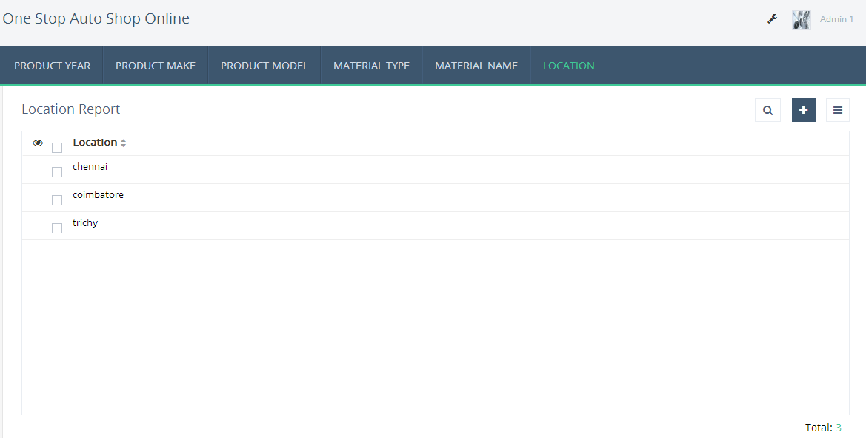

**E.Create the Location Pincode Form:**

**Scenario**

The Sales Management stores all its Location Pin code details in an .xls file. We will now import this Location Pin code data into One Stop Auto Shop Online app. To import the Location Pincode data to the app,

1. Click on **Create New – Form**



2. Select the **Import File** icon from the New Form page.

3. Download the sample Location pincode file from the below link:

https://goo.gl/LqJF86

4. Browse and select the downloaded l .xls file which holds the Material Type data and click on **Attach**

5. Click on **Create** to create an form from the input file.

6. The“importing data” dialog will display the data from the excel file. Zoho creator automatically defines the field type based on the type of data stored in each column of the spreadsheet.To change the Field type for a column, select appropriate type from the drop-down list. For example, the data type for **Type** is displayed as **Single Line**. To view the List of Product Year available and choose the required Product Year from the list, we will change the field type from **Single Line** to **Drop-down**.

The data in the first row will be displayed as the default **Label Name** for each column. If the options **consider first row as Label Names** is unchecked, the Label Name will be left blank. You can type a new names in the Label Name box or modify the displayed names.

7. Click **Finish** to create the form with the Location Pincode data. The form is created and you land on Location Pincode Form Page. Notice that Zoho Creator automatically creates the Form and all the label names in the spreadsheet has become the Form Field names. New Location Pincode data will be updated through this Form

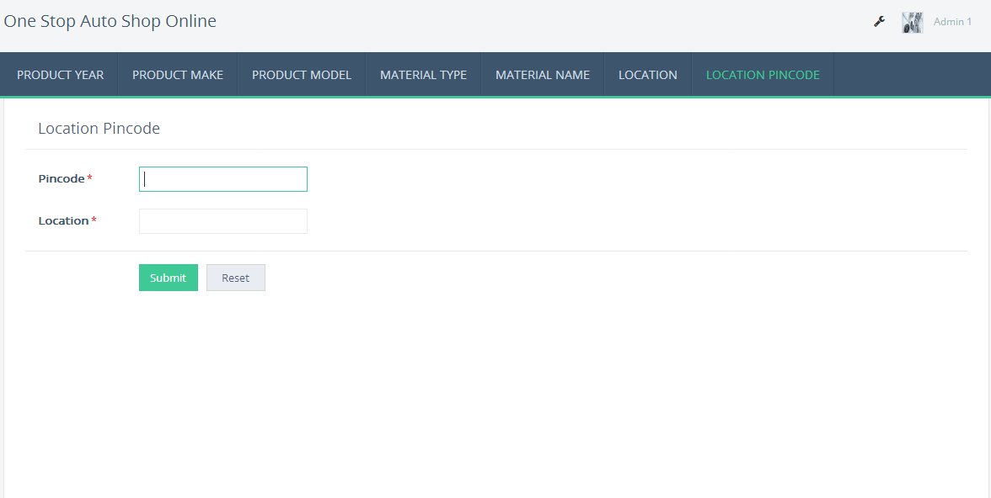

8. The data in the spreadsheet is updated in the Location Pincode report. Click on Location Pincode Report to view the Location Pincode data uploaded from the spreadsheet.

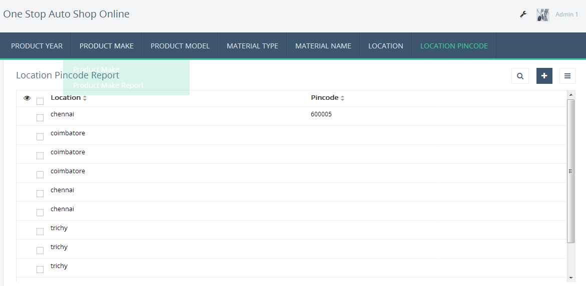

2. Create Lookup Relation

a. Open the Form builder and drag-and-drop the **lookup field** on the **Location Pincode** Form.

b. A pop up appears that needs you to choose the **Applications – Forms – Fields** to which you want the **Location** Form to relate to.

c. Select **Location - Location.**

d. Select the Display type as **Drop-down** so that only one product type can be selected from the list.

e. Click on **Done** to save the changes.

f. Specify the Field name as **Location**. The **Location Pincode** Form is now linked with the **Location** Form through the **Location** field.

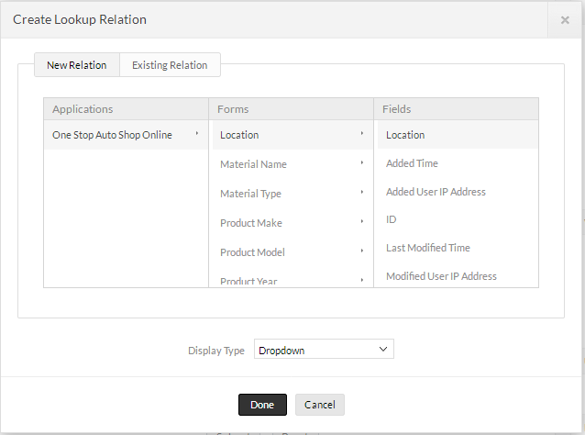

2. Access the App

a. Click on **Access this application** on the top right corner. You will be redirected to the livemode of this application.

b. In the live mode, you can see the two Forms created by you.Each Form is present under the header of the Form name.

c. Fill in the **Location Pincode** with sample entries. This is how relationship between two Forms is achieved.

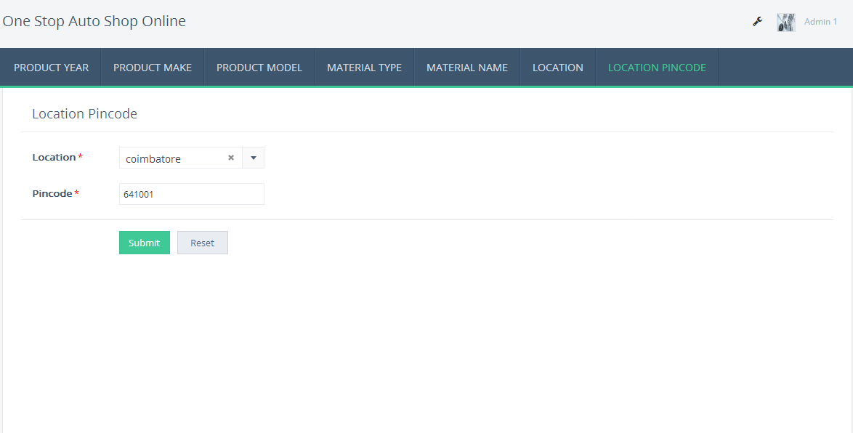

**Lesson 8: Create Materials Inventory Form – Use Filter in Lookup**

**Scenario**

So, let us start with creating the Material Inventory Form. This Form will be used to manage Materials Stock accessed by Admin.

1. In Form Properties, enter Form Name as **Material Inventory**. Now, add the following Fields to the Form.

○ Add Availability Field to enter the Material Availability by the admin

▪ From the Fields List, drag and drop a **Number** field to the top of the Material Inventory Form.

▪ On the right side of form editor, on the **Field Properties** Configuration object,for Field Name **Availability**.

▪ In the Validation configuration box, check the **Mandatory** check-box.

○ Add Price Per Material Field to store each material price by the admin

▪ From the Fields List, drag and drop a **Currency** field below the Availability field.

▪ On the right side of form editor, on the Field Properties Configuration object, for Field Name **Price Per Material.**

▪ In the Validation configuration box, check the mandatory check-box.

**Link the Multiple form With Material Inventory Form**

**Scenario**

We will now replace the add the Multiple Lookup field in Material Inventory Form that will automatically display all the Product Year, Product make, Product Model,Material Type,Material Name as a list from the Forms Product Year,Product make,Product Model,Material Type and Material Name . A lookup field relates two Forms and displays a drop-down menu displaying item from the Source Form. Let us create a **lookup field** in the Material Inventory Form to relate it with the Product Year,Product make,Product Model,Material Type,Material Name Forms. This allows the Product Year,Product make,Product Model,Material Type,Material Name data in the **Material Inventory** Form.

1. Create Lookup Relation

a. Open the Form builder and drag-and-drop the **lookup field** on the **Material Inventory** Form.

b. A pop up appears that needs you to choose the **Applications – Forms –Fields** to which you want the Material Inventory Form to relate to.

c. Select **Product Year - Year**.

d. Select the Display type as **Drop-down** so that only one **Year** can be selected from the list.

e. Click on **Done** to save the changes.

f. Specify the Field name as **Product Year**. The **Product Year** Form is now linked with the **Material Inventory** Form through the **Year** field.

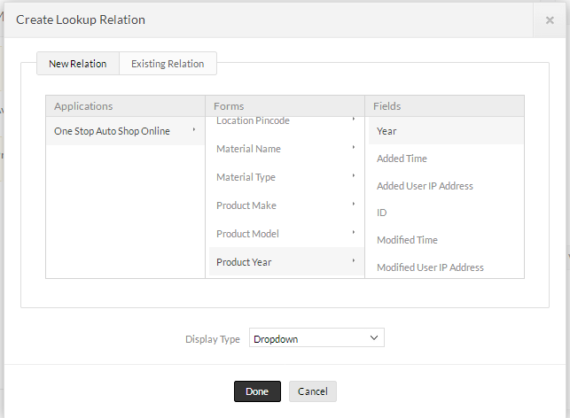

2. Create Lookup Relation with Set Filter Criteria

a. Open the Form builder and drag-and-drop the **lookup field** on the **Material Inventory** Form.

b. A pop up appears that needs you to choose the **Applications – Forms –Fields** to which you want the Material Inventory Form to relate to.

c. Select **Product Make - Product Make**.

d. Select the Display type as **Drop-down** so that only one **Product Make** can be selected from the list.

e. Click on **Done** to save the changes.

f. In Field Properties select the Set Filter check box and Set Filter pop-up will appear choose the field,operators and input field name.Here we going to set a filter criteria,

**ID == input.Product_Year.**

g. Specify the Field name as **Product Make**. The **Product Make** Form is now linked with the **Material Inventory** Form through the **Product Make** field.

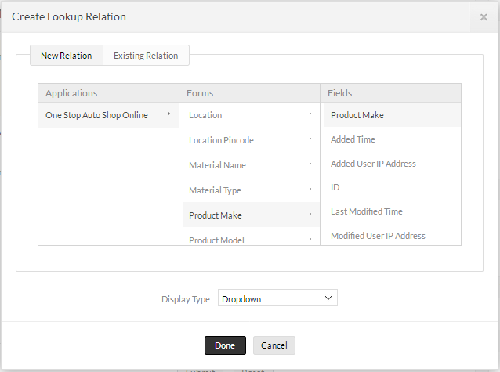

3. Create Lookup Relation with Set Filter Criteria

a. Open the Form builder and drag-and-drop the **lookup field** on the **Material Inventory** Form.

b. A pop up appears that needs you to choose the **Applications – Forms – Fields** to which you want the Material Inventory Form to relate to.

c. Select **Product Model - Product Model**.

d. Select the Display type as **Drop-down** so that only one **Product Model** can be selected from the list.

e. Click on **Done** to save the changes.

.f. In Field Properties select the Set Filter check box and Set Filter pop-up will appear choose the field,operators and input field name.Here we going to set a filter criteria,

**ID == input.Product_Year && ID == input.Product_Model.**

g. Specify the Field name as **Product Model**. The **Product Model** Form is now linked with the **Material Inventory** Form through the **Product Model** field.



4. Create Lookup Relation with Set Filter Criteria

a. Open the Form builder and drag-and-drop the **lookup field** on the **Material Inventory** Form.

b. A pop up appears that needs you to choose the **Applications – Forms –Fields** to which you want the Material Inventory Form to relate to.

c. Select **Material Type - Material Type**.

d. Select the Display type as **Drop-down** so that only one **Material Type** can be selected from the list.

e. Click on **Done** to save the changes.

f. Specify the Field name as **Material Type**. The **Material Type** Form is now linked with the **Material Inventory** Form through the **Year** field.

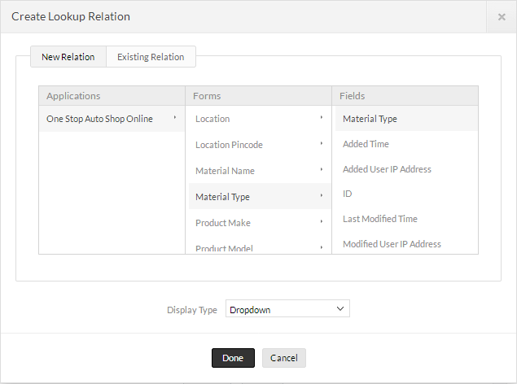

5. Create Lookup Relation with Set Filter Criteria

a. Open the Form builder and drag-and-drop the **lookup field** on the **Material Inventory** Form.

b. A pop up appears that needs you to choose the **Applications – Forms –Fields** to which you want the Material Inventory Form to relate to.

c. Select **Material Name - Material Name**.

d. Select the Display type as **Drop-down** so that only one **Material Name** can be selected from the list.

e. Click on **Done** to save the changes.

f. In Field Properties select the Set Filter check box and Set Filter pop-up will appear choose the field,operators and input field name.Here we going to set a filter criteria,

**ID == input.Material_Type.**

g. Specify the Field name as **Material Name**. The **Material Name** Form is now linked with the **Material Inventory** Form through the **Material Name** field.

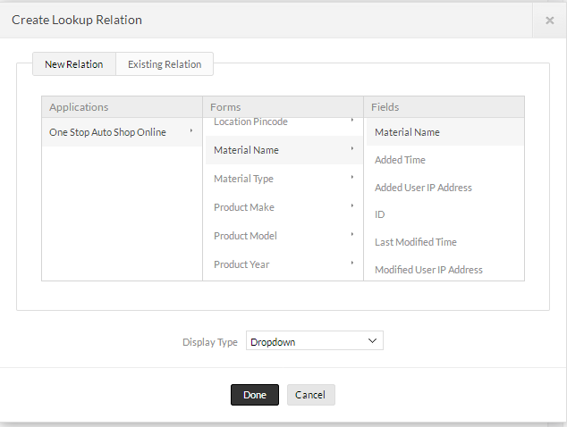

3. Access the App

a. Click on **Access this application** on the top right corner. You will be redirected to the live mode of this application.

b. In the live mode, you can see the Forms created by you. Each Form is present under the header of the Form name.

c. Fill in the **Material** **Inventory** with sample entries. This is Lookup with set filter is achieved.

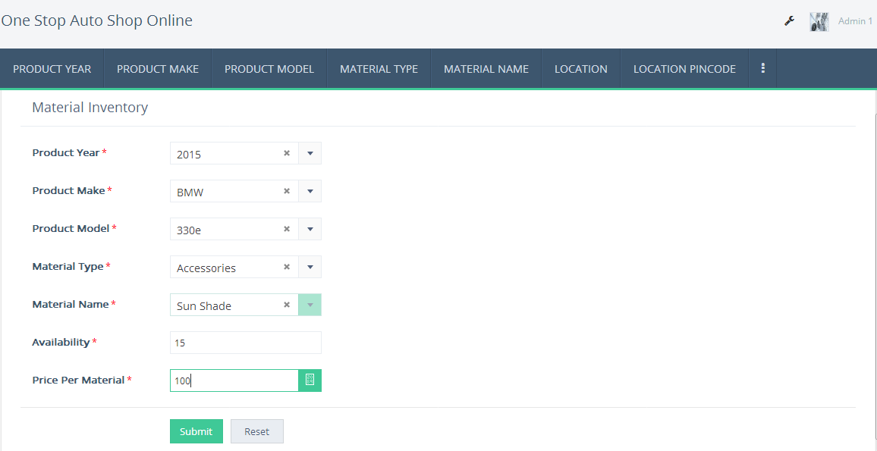

**Lesson 9 : Create an Order Form using From Template**

**Scenario**

The Sales Management app, the materials which is ready for sales should be manage and verify by calculating the total price. We will now create the Order Form handles the single order with the calculation of total price.

1. In Form Properties, enter Form Name as **Order Form**. Now, add the following Fields to the Form.

○ Add Availability Field to enter the Availability

▪ From the Fields List, drag and drop a **Number** field to the Below the Material Name field.

▪ On the right side of form editor, on the **Field Properties** Configuration object,for Field Name **Availability**.

▪ In the Validation configuration box, check the **Mandatory** check-box.

○ Add Quantity Required Field to enter the Quantity Required by the Customer

▪ From the Fields List, drag and drop a **Number** field below the Availability Form.

▪ On the right side of form editor, on the **Field Properties** Configuration object,for Field Name **Quantity Required.**

▪ In the Validation configuration box, check the **Mandatory** check-box.

○ Add Price Per Material Field to store each material price

▪ From the Fields List, drag and drop a **Currency** field below the Quantity Required field.

▪ On the right side of form editor, on the Field Properties Configuration object, for Field Name **Price Per Material.**

▪ In the Validation configuration box, check the Mandatory check-box.

* Add Total Price Field to calculate total price for material price

▪ From the Fields List, drag and drop a **Currency** field below the Price Per Material field.

▪ On the right side of form editor, on the Field Properties Configuration object, for Field Name **Total** **Price.**

▪ In the Validation configuration box, check the Mandatory check-box.

**Link the Multiple form With Order Form**

**Scenario**

We will now replace the add the Multiple Lookup field in Order Form that will automatically display all the Product Year,Product make,Product Model,Material Type,Material Name as a list from the Forms Product Year,Product make,Product Model,Material Type and Material Name . A lookup field relates two Forms and displays a drop-down menu displaying item from the Source Form. Let us create a **lookup field** in the Order Form to relate it with the Product Year,Product make,Product Model,Material Type,Material Name Forms. This allows the Product Year,Product make,Product Model,Material Type,Material Name added in the **Order** Form.

1. Create Lookup Relation

a. Open the Form builder and drag-and-drop the **lookup field** on the **Material Inventory** Form.

b. A pop up appears that needs you to choose the **Applications – Forms –Fields** to which you want the Material Inventory Form to relate to.

c. Select **Product Year - Year**.

d. Select the Display type as **Drop-down** so that only one **Year** can be selected from the list.

e. Click on **Done** to save the changes.

f. Specify the Field name as **Product Year**. The **Product Year** Form is now linked with the **Material Inventory** Form through the **Year** field.

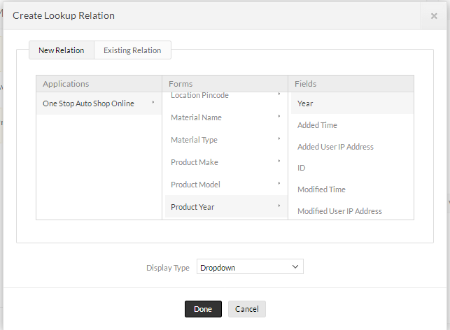

2. Create Lookup Relation with Set Filter Criteria

a. Open the Form builder and drag-and-drop the **lookup field** on the **Material Inventory** Form.

b. A pop up appears that needs you to choose the **Applications – Forms –Fields** to which you want the Material Inventory Form to relate to.

c. Select **Product Make - Product Make**.

d. Select the Display type as **Drop-down** so that only one **Product Make** can be selected from the list.

e. Click on **Done** to save the changes.

f. In Field Properties select the Set Filter check box and Set Filter pop-up will appear choose the field,operators and input field name.Here we going to set a filter criteria,

**ID == input.Product_Year.**

g. Specify the Field name as **Product Make**. The **Product Make** Form is now linked with the **Material Inventory** Form through the **Product Make** field.

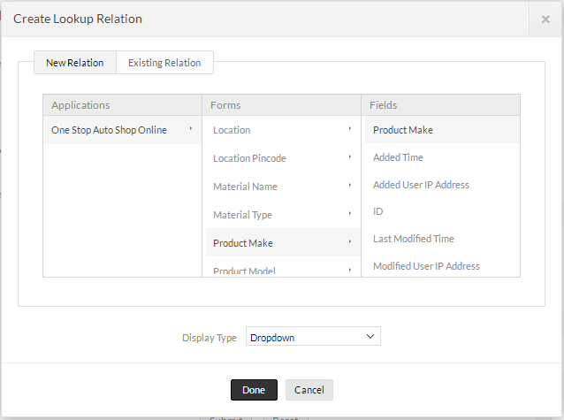

3. Create Lookup Relation with Set Filter Criteria

a. Open the Form builder and drag-and-drop the **lookup field** on the **Material Inventory** Form.

b. A pop up appears that needs you to choose the **Applications – Forms – Fields** to which you want the Material Inventory Form to relate to.

c. Select **Product Model - Product Model**.

d. Select the Display type as **Drop-down** so that only one **Product Model** can be selected from the list.

e. Click on **Done** to save the changes.

f. In Field Properties select the Set Filter check box and Set Filter pop-up will appear choose the field,operators and input field name.Here we going to set a filter criteria,

**ID == input.Product_Year && ID == input.Product_Model.**

g. Specify the Field name as **Product Model**. The **Product Model** Form is now linked with the **Material Inventory** Form through the **Product Model** field.



4. Create Lookup Relation with Set Filter Criteria

a. Open the Form builder and drag-and-drop the **lookup field** on the **Material Inventory** Form.

b. A pop up appears that needs you to choose the **Applications – Forms –Fields** to which you want the Material Inventory Form to relate to.

c. Select **Material Type - Material Type**.

d. Select the Display type as **Drop-down** so that only one **Material Type** can be selected from the list.

e. Click on **Done** to save the changes.

f. Specify the Field name as **Material Type**. The **Material Type** Form is now linked with the **Material Inventory** Form through the **Year** field.

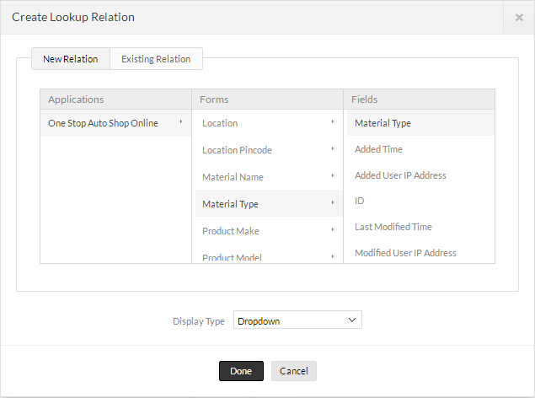

5. Create Lookup Relation with Set Filter Criteria

a. Open the Form builder and drag-and-drop the **lookup field** on the **Material Inventory** Form.

b. A pop up appears that needs you to choose the **Applications – Forms – Fields** to which you want the Material Inventory Form to relate to.

c. Select **Material Name - Material Name**.

d. Select the Display type as **Drop-down** so that only one **Material Name** can be selected from the list.

e. Click on **Done** to save the changes.

f. In Field Properties select the Set Filter check box and Set Filter pop-up will appear choose the field,operators and input field name.Here we going to set a filter criteria,

**ID == input.Material_Type.**

g. Specify the Field name as **Material Name**. The **Material Name** Form is now linked with the **Material Inventory** Form through the **Material Name** field.

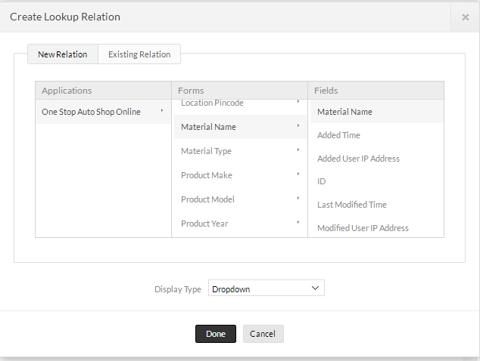

3. Access the App

a. Click on **Access this application** on the top right corner. You will be redirected to the live mode of this application.

b. In the live mode, you can see the Forms created by you. Each Form is present under the header of the Form name.

c. Fill in the **Material** **Inventory** with sample entries. This is Lookup with set filter is achieved.

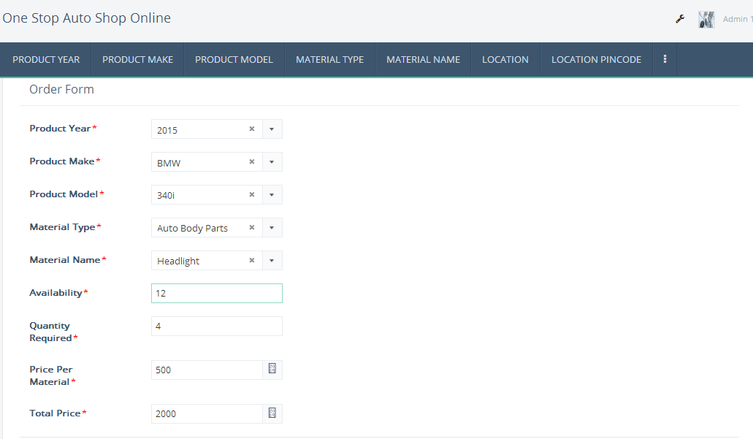

**Lesson 10 :**   **Create a Customer Inquiry Form**

**Scenario**

The Sales Management app used Store the Customer Details. We will now create the Customer Inquiry Form in One Stop Auto Shop Online app.

1. In Form Properties, enter Form Name as **Customer Inquiry**. Now, add the following Fields to the Form.

○ Add Customer Name Field to enter the Name of the Customer

▪ From the Fields List, drag and drop a **Single Line** field to the top of the Customer Inquiry Form.

▪ On the right side of form editor, on the **Field Properties** Configuration object,for Field Name **Customer Name.**

▪ In the Validation configuration box, check the **Mandatory** check-box.

○ Add Contact Number Field to enter the Contact Details of the Customer

▪ From the Fields List, drag and drop a **Single Line** field to the below the Customer Name Field.

▪ On the right side of form editor, on the **Field Properties** Configuration object,for Field Name **Contact Number.**

▪ In the Validation configuration box, check the **Mandatory** check-box.

○ Add Email Field to store mail id of the Customer

▪ From the Fields List, drag and drop a **Email** field below the Contact Number.

▪ On the right side of form editor, on the Field Properties Configuration object, for Field Name **Email.**

▪ In the Validation configuration box, check the Mandatory check-box.

* Add Address Field to add the address of the customer

▪ From the Fields List, drag and drop a **Multiline** field below the Email field.

▪ On the right side of form editor, on the Field Properties Configuration object, for Field Name **Address.**

▪ In the Validation configuration box, check the Mandatory check-box.

* Add Customer ID Field to store the ID for each customer

▪ From the Fields List, drag and drop a **Auto Number** field below the Address field.

▪ On the right side of form editor, on the Field Properties Configuration object, for Field Name **Customer ID.**

▪ In the Validation configuration box, check the Mandatory check-box.

2. Verify that the Form looks like the following image

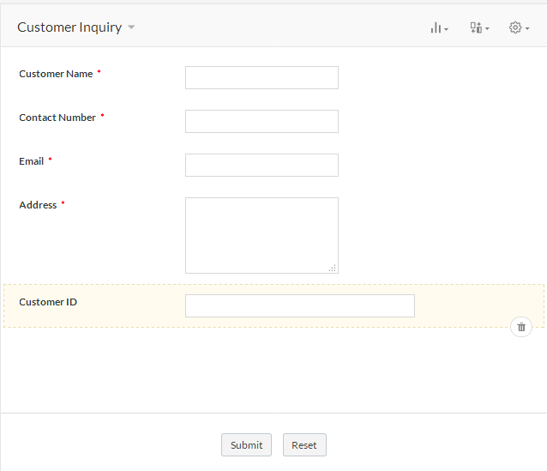

**Lesson 11: Create Place Order Form with Subform**

**Scenario**

The Order Form that we have created in the Sales Management app enables customer to order only a single order per material. To allow clients to order more materials, we will create a **Place Order** Form with a sub - form. A sub - form is a form within a form. The primary form is called the Main Form, and the form that is inserted in the Main Form is called the Sub - Form. Sub - Form are generally used to show data from tables that have a one-to-many relationship. For example, to order with **Place Order** details.

1. In Form Properties, enter Form Name as **Customer Inquiry**. Now, add the following Fields to the Form.

○ Add Customer Name Field to enter the Name of the Customer

▪ From the Fields List, drag and drop a **Single Line** field to the top of the Customer Inquiry Form.

▪ On the right side of form editor, on the **Field Properties** Configuration object,for Field Name **Customer Name.**

▪ In the Validation configuration box, check the **Mandatory** check-box.

○ Add Contact Number Field to enter the Contact Details of the Customer

▪ From the Fields List, drag and drop a **Single Lin** field to the below the Customer Name Field.

▪ On the right side of form editor, on the **Field Properties** Configuration object,for Field Name **Contact Number.**

▪ In the Validation configuration box, check the **Mandatory** check-box.

○ Add Email Field to store mail id of the Customer

▪ From the Fields List, drag and drop a **Email** field below the Contact Number.

▪ On the right side of form editor, on the Field Properties Configuration object, for Field Name **Email.**

▪ In the Validation configuration box, check the Mandatory check-box.

* Add Address Field to add the address of the customer

▪ From the Fields List, drag and drop a **Multiline** field below the Email field.

▪ On the right side of form editor, on the Field Properties Configuration object, for Field Name **Address.**

▪ In the Validation configuration box, check the Mandatory check-box.

* Add Date Field to add the Date Of Ordering

▪ From the Fields List, drag and drop a **Date** field below the Address field.

▪ On the right side of form editor, on the Field Properties Configuration object, for Field Name **Date Of Ordering.**

▪ In the Validation configuration box, check the Mandatory check-box.

* Add Decimal Field to add the Delivery Within(in days)

▪ From the Fields List, drag and drop a **Decimal** field below the Date Of Ordering field.

▪ On the right side of form editor, on the Field Properties Configuration object, for Field Name **Delivered Within (in days ).**

▪ In the Validation configuration box, check the Mandatory check-box.

* Add Date Field to add the Date Of Ordering

▪ From the Fields List, drag and drop a **Date** field below the Delivery Within.

▪ On the right side of form editor, on the Field Properties Configuration object, for Field Name **Expected Delivery Date.**

▪ In the Validation configuration box, check the Mandatory check-box.

* From the Fields list, drag and drop a Sub- Form field on the Form, below the Date of Booking Field. The Sub - Form –>Blank/Existing Form dialog box appears.
* Select the Existing Form – **Order** **Form** and click on Done.
* On the right side of form editor, on the Field Properties Configuration object, for Field Name **Order Details**.
* Add Currency Field to Calculate the Final Price

▪ From the Fields List, drag and drop a **Currency** field below the Ordering Details.

▪ On the right side of form editor, on the Field Properties Configuration object, for Field Name **Final Price.**

▪ In the Validation configuration box, check the Mandatory check-box.

* Add Drop Down Field to list the Status

▪ From the Fields List, drag and drop a **Drop Down** field below the Final Price.

▪ On the right side of form editor, on the Field Properties Configuration object, for Field Name **Status.**

* In properties,add choices to status as Confirmed and Not Confirmed.Make a select of Not Confirmed

▪ In the Validation configuration box, check the Mandatory check-box.

**Link the Location,Pincode Location forms With Place Order Form**

**Scenario**

We will now replace the add the Lookup field in Place Order Form that will automatically display all the Location and Pincode Location as a list from the Forms Location and Pincode Location. A lookup field relates two Forms and displays a drop-down menu displaying item from the Source Form. Let us create a **lookup field** in the Place Order Form to relate it with the Location and Pincode Location Forms. This allows the Location and Pincode Location added in the **Place** **Order** Form.

1. Create Lookup Relation

a. Open the Form builder and drag-and-drop the **lookup field** on the **Place Order** Form.

b. A pop up appears that needs you to choose the **Applications – Forms –Fields** to which you want the Material Inventory Form to relate to.

c. Select **Location - Location**.

d. Select the Display type as **Drop-down** so that only one **Location** can be selected from the list.

e. Click on **Done** to save the changes.

f. Specify the Field name as **Location**. The **Location** Form is now linked with the **Place Order** Form through the **Location** field.

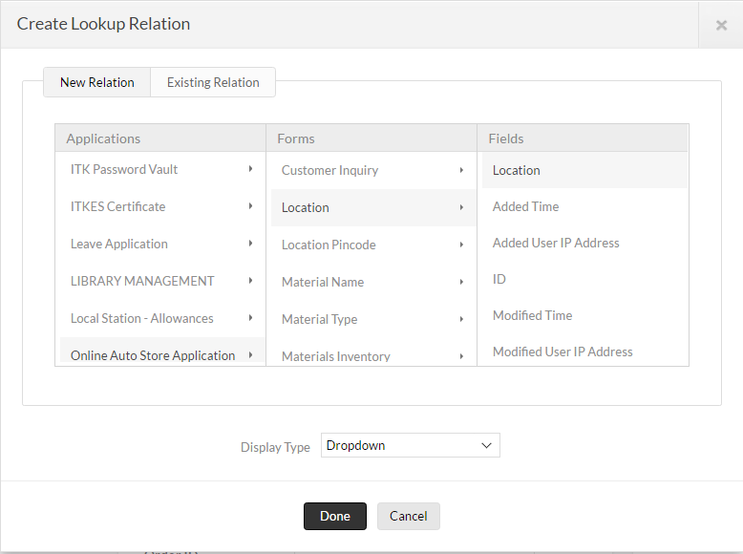

2.Create Lookup Relation

a. Open the Form builder and drag-and-drop the **lookup field** on the **Place Order** Form.

b. A pop up appears that needs you to choose the **Applications – Forms –Fields** to which you want the Material Inventory Form to relate to.

c. Select **Location Pincode - Pincode.**

d. Select the Display type as **Drop-down** so that only one **Pincode** can be selected from the list.

e. Click on **Done** to save the changes.

f. Specify the Field name as **Location Pincode**. The **Location** **Pincode** Form is now linked with the **Place Order** Form through the **Location** **Pincode** field.

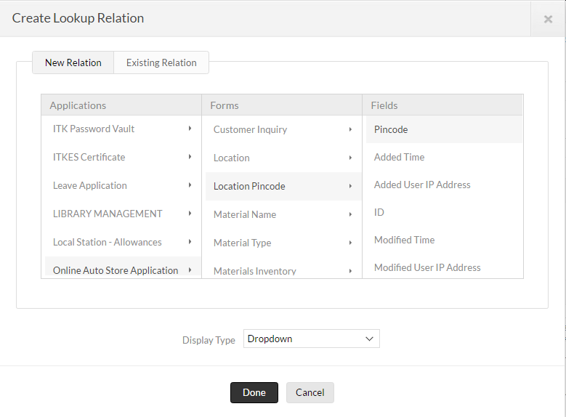

3.Create Lookup Relation

a. Open the Form builder and drag-and-drop the **lookup field** on the **Place Order** Form.

b. A pop up appears that needs you to choose the **Applications – Forms –Fields** to which you want the Material Inventory Form to relate to.

c. Select **Customer Inquiry - Customer Name**.

d. Select the Display type as **Drop-down** so that only one **Customer Name** can be selected from the list.

e. Click on **Done** to save the changes.

f. Specify the Field name as **Customer Name**. The **Customer Inquiry** Form is now linked with the **Place Order** Form through the **Customer Name** field.

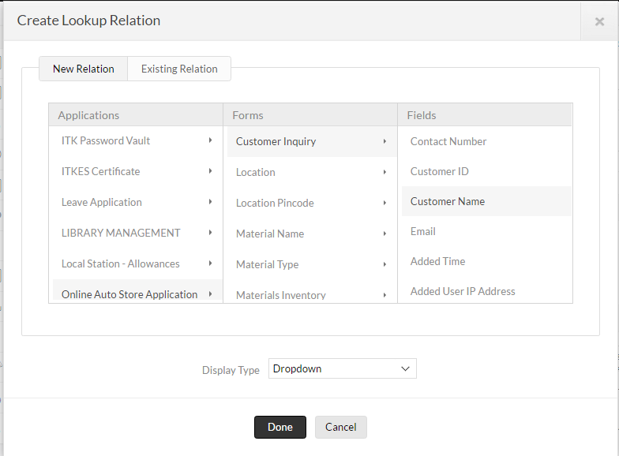

3.Access the App

a. Click on **Access this application** on the top right corner. You will be redirected to the live mode of this application.

b. In the live mode, you can see the Forms created by you. Each Form is present under the header of the Form name.

c. Fill in the **Place Order** with sample entries. This is Lookup with set filter is achieved.

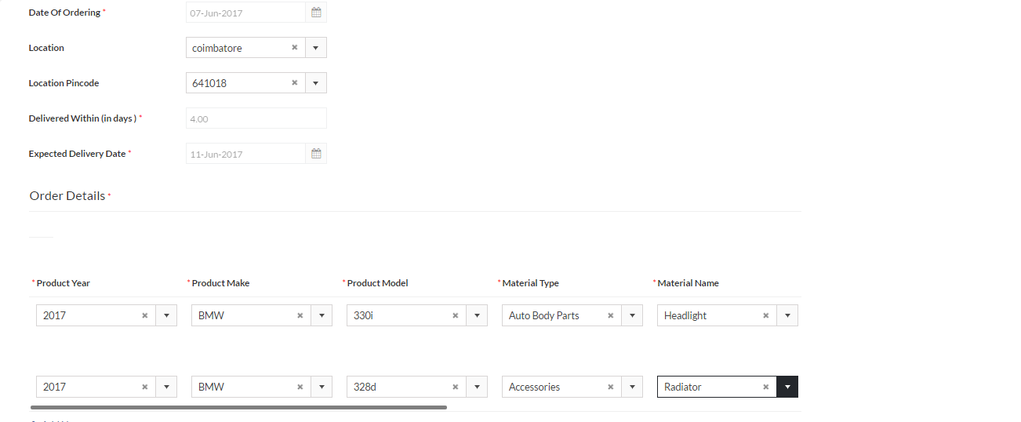

**Lesson 12:**. **Date Validation**

**Scenario**

The Place Order Form that we have created in the Sales Management app enables the customer to Find the Expected Delivery Date based on the Date Of Ordering.

Here we are required to do some Condition for the Sales Management app to be consistent.

1. When the customer selects the Date Of Ordering, it should be the current date.

2. Based on the Pin code we are setting the Expected Delivery Date.

The steps to automate the workflow are given below.

● Verify that the **Order Form**  in the Form Builder

● On the workflow page, you can see that **Field Actions – Location Pincode – On User Input** is selected.

● Drag and drop **if** task from Deluge Task list to the Script Builder area, to write the validating condition.

Write the Code as shown in the below Image.

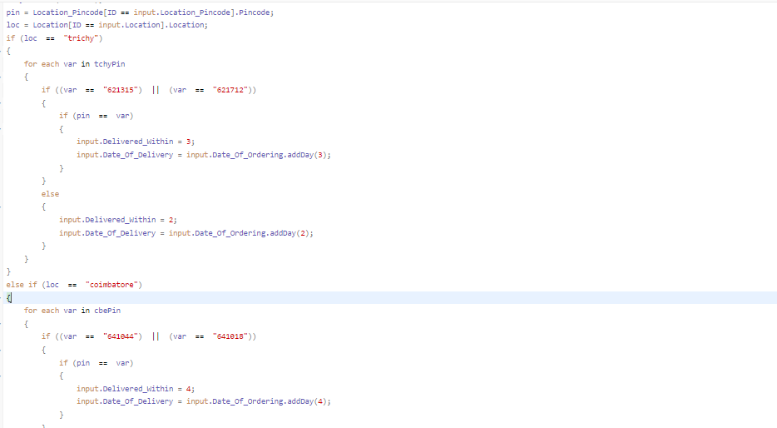

* At the bottom of the Free-flow scripting window, select **SaveScript**.

* At the top of the Free-flow scripting window, verify the status message says **saved.**

* On the Zoho Creator menu, select **Access this Application.**

**Lesson 13: Fetch Product Price and Availability**

**Scenario**

Now we will add workflows to the Booking Form to calculate Final Price of Booking.

a. Verify that the **Place Order Form** appears in the Form Builder.

b. Select the **Product Year** in the Sub Form **Room**.

c. Select the **Product Model** Field in the Sub Form **Room**.

d. Select the **Product Make,Material Type** and **Material Name**

e. To fetch **Availability and Price** value when the user selects the **Material Name**

Go To ,

**Place Order Form --> Field Actions -->Material Name --> on User Input** is

selected. Write the below code in **Free-flow Scripting** and **Save Script**.

f. **Total Price** will be calculated. Write the Code as shown in the below Image.

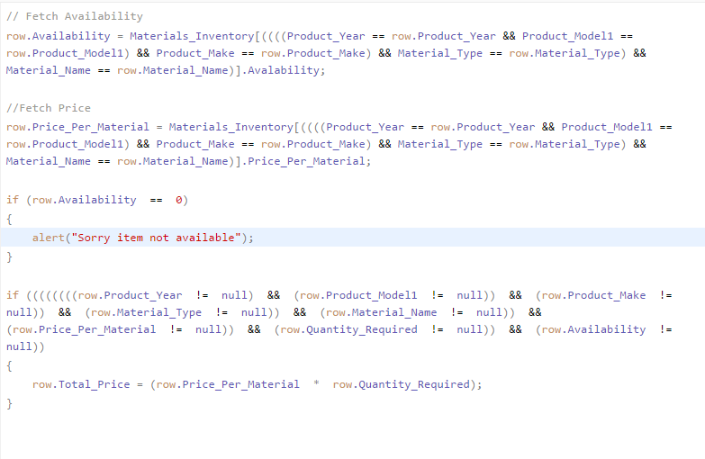

g. At the bottom of the Free-flow scripting window, select **SaveScript**.

h. At the top of the Free-flow scripting window, verify the status message says **saved.**

i. On the Zoho Creator menu, select **Access this Application.**

**Lesson 14: Calculate the Final Price for each product and required quantity**

**Scenario**

Now we will add workflows to the Booking Form to calculate Final Price of Booking.

a. Verify that the **Place Order Form** appears in the Form Builder.

b. Enter the **Quantity Required** in the Total price and **Final Price** will calculate for **Place Order** Form.

The steps to automate the workflow are given below.

● Verify that the **Place** **Order Form** in the Form Builder

● On the workflow page, you can see that **Field Actions – Quantity Required – On User Input** is selected.

● Go to Free Flow Scripting to write the Calculation Coding.Write the Code as shown in the below Image

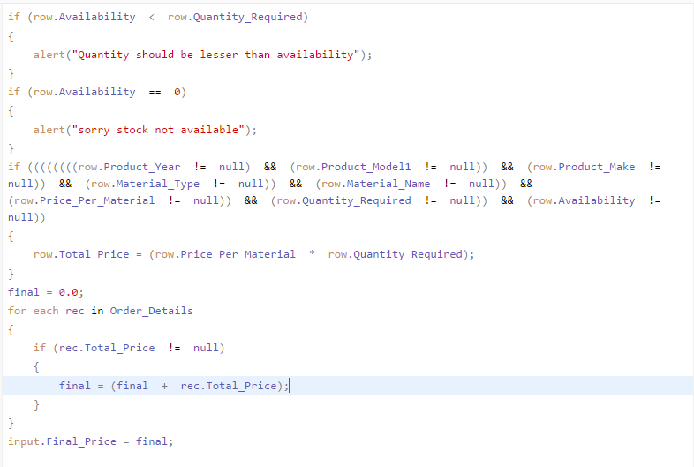

**Lesson 15: Place the Final Price calculation in On User Input action wherever required**

**Scenario**

Now we will add workflows to the Place Order Form to calculate Final Price.when the customer changes the Product Year,Product Make,Product Model,Material Type and Material Name fields in the sub-form then final price and total price will change.So we need add the final price and total price coding wherever its required.

. a. Under **Field Properties** click **Configure field actions**.

b. On the Workflow page, you can see that **Field Actions –> Product_Year –>on User**

**Input** is selected.

c. Go to Free Flow Scripting to write the Calculation Coding.Write the Code as shown in

the below Image

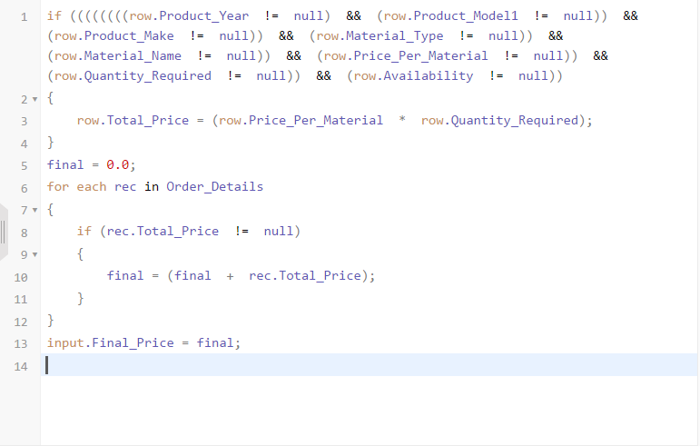

d. At the bottom of the Free-flow scripting window, select **SaveScript**. At the top of the

Free-flow scripting window, verify the status message says **saved.**i. On the Zoho

Creator menu, select **Access this Application**

e. On the Workflow page, you can see that **Field Actions –> Product_Make –>on Use**

**Input** is selected.

f. Go to Free Flow Scripting to write the Calculation Coding.Write the Code as shown

in the below Image



g. At the bottom of the Free-flow scripting window, select **SaveScript**. At the top of the

Free-flow scripting window, verify the status message says **saved.**i. On the Zoho

Creator menu, select **Access this Application**

h. On the Workflow page, you can see that **Field Actions –> Product_Model –>on**

**User Input** is selected.

i. Go to Free Flow Scripting to write the Calculation Coding.Write the Code as shown

in the below Image



j. At the bottom of the Free-flow scripting window, select **SaveScript**. At the top of the

Free-flow scripting window, verify the status message says **saved.**i. On the Zoho

Creator menu, select **Access this Application**

k. On the Workflow page, you can see that **Field Actions –> Material_Type –>on U**

**Input** is selected.

l. Go to Free Flow Scripting to write the Calculation Coding.Write the Code as show

in the below Image



m. At the bottom of the Free-flow scripting window, select **SaveScript**. At the top of the

Free-flow scripting window, verify the status message says **saved.**i. On the Zoho Creator

menu, select **Access this Application**

n. On the Workflow page, you can see that **Field Actions –> Material_Name –>on**

**Input** is selected.

o. Go to Free Flow Scripting to write the Calculation Coding.Write the Code as sho

in the below Image



p. At the bottom of the Free-flow scripting window, select **SaveScript**. At the top of the

Free-flow scripting window, verify the status message says **saved.** On the Zoho Creator

menu, select **Access this Application**

**Lesson 16: Check Availability of Stocks**

**Scenario**

The Place Order Form that we have created in the Sales management app enables the customer to select the Material Type and Product data's.

1. when the customer selects the Material _Name , it should check the availability not be less than the 1. Alert Message will pop up.

The steps to automate the workflow are given below.

● Verify that the **Place Order Form** in the Form Builder

● Go to the **Field Properties** of sub -form, click **Configure Field Actions.**

● On the workflow page, you can see that **Field Actions – Material_Name – On User Input** is selected.

● Drag and drop **if** task from Deluge Task list to the Script Builder area, to write the validating condition.

Write the Code as shown in the below Image

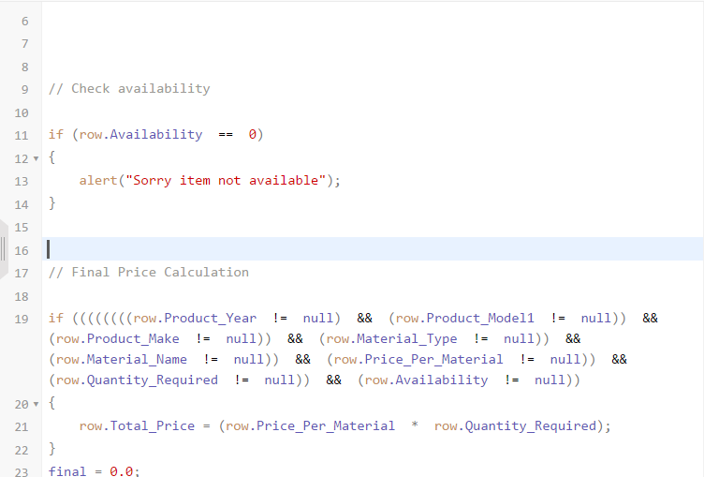



* At the bottom of the Free-flow scripting window, select **SaveScript**.
* At the top of the Free-flow scripting window, verify the status message says **saved.**
* On the Zoho Creator menu, select **Access this Application**

**Lesson 17: Create a Form Minimum Stock**

**Scenario**

Now, let us start with creating the Minimum Stock Form. This Form will be used to maintain Minimum Stock .

1. Click on **Create New – Form**



2. Select the From Scratch radio button in create new form template and the enter the

Name of the Form as Minimum Stock.Then Click Create button to create the new

Form

3. In Form Properties, enter Form Name as **Minimum Stock**. Now, add the following Fields to the Form.

○ Add Availability Field to enter the Material Availability by the admin

▪ From the Fields List, drag and drop a **Number** field to the top of the Minimum Stock Form.

▪ On the right side of form editor, on the **Field Properties** Configuration object,for Field Name **Availability**.

▪ In the Validation configuration box, check the **Mandatory** check-box.

○ Add Price Per Material Field to store each material price by the admin

▪ From the Fields List, drag and drop a **Currency** field below the Availability field.

▪ On the right side of form editor, on the Field Properties Configuration object, for Field Name **Price Per Material.**

▪ In the Validation configuration box, check the Mandatory check-box.

**Link the Multiple form With Minimum Stock Form**

**Scenario**

We will now replace the add the Multiple Lookup field in Minimum Stock Form that will automatically display all the Product Year,Product make,Product Model,Material Type,Material Name as a list from the Forms Product Year,Product make,Product Model,Material Type and Material Name . A lookup field relates two Forms and displays a drop-down menu displaying item from the Source Form. Let us create a **lookup field** in the Material Inventory Form to relate it with the Product Year,Product make,Product Model,Material Type,Material Name Forms. This allows the Product Year,Product make,Product Model,Material Type,Material Name data in the **Material Inventory** Form.

1. Create Lookup Relation

a. Open the Form builder and drag-and-drop the **lookup field** on the **Minimum Stock** Form.

b. A pop up appears that needs you to choose the **Applications – Forms –Fields** to which you want the Minimum StockForm to relate to.

c. Select **Product Year - Year**.

d. Select the Display type as **Drop-down** so that only one **Year** can be selected from the list.

e. Click on **Done** to save the changes.

f. Specify the Field name as **Product Year**. The **Product Year** Form is now linked with the **Minimum Stock** Form through the **Year** field.



2. Create Lookup Relation with Set Filter Criteria

a. Open the Form builder and drag-and-drop the **lookup field** on the **Minimum Stock** Form.

b. A pop up appears that needs you to choose the **Applications – Forms –Fields** to which you want the Minimum Stock Form to relate to.

c. Select **Product Make - Product Make**.

d. Select the Display type as **Drop-down** so that only one **Product Make** can be selected from the list.

e. Click on **Done** to save the changes.

f. In Field Properties select the Set Filter check box and Set Filter pop-up will appear choose the field,operators and input field name.Here we going to set a filter criteria,

**ID == input.Product_Year.**

g. Specify the Field name as **Product Make**. The **Product Make** Form is now linked with the **Minimum Stock** Form through the **Product Make** field.



3. Create Lookup Relation with Set Filter Criteria

a. Open the Form builder and drag-and-drop the **lookup field** on the **Minimum Stock** Form.

b. A pop up appears that needs you to choose the **Applications – Forms – Fields** to which you want the Minimum Stock Form to relate to.

c. Select **Product Model - Product Model**.

d. Select the Display type as **Drop-down** so that only one **Product Model** can be selected from the list.

e. Click on **Done** to save the changes.

f. In Field Properties select the Set Filter check box and Set Filter pop-up will appear choose the field,operators and input field name.Here we going to set a filter criteria,

**ID == input.Product_Year && ID == input.Product_Model.**

g. Specify the Field name as **Product Model**. The **Product Model** Form is now linked with the **Minimum Stock** Form through the **Product Model** field.



4. Create Lookup Relation with Set Filter Criteria

a. Open the Form builder and drag-and-drop the **lookup field** on the **Minimum Stock** Form.

b. A pop up appears that needs you to choose the **Applications – Forms –Fields** to which you want the Material Inventory Form to relate to.

c. Select **Material Type - Material Type**.

d. Select the Display type as **Drop-down** so that only one **Material Type** can be selected from the list.

e. Click on **Done** to save the changes.

f. Specify the Field name as **Material Type**. The **Material Type** Form is now linked with the **Minimum Stock** Form through the **Year** field.



5. Create Lookup Relation with Set Filter Criteria

a. Open the Form builder and drag-and-drop the **lookup field** on the **Minimum Stock** Form.

b. A pop up appears that needs you to choose the **Applications – Forms –Fields** to which you want the Material Inventory Form to relate to.

c. Select **Material Name - Material Name**.

d. Select the Display type as **Drop-down** so that only one **Material Name** can be selected from the list.

e. Click on **Done** to save the changes.

f. In Field Properties select the Set Filter check box and Set Filter pop-up will appear choose the field,operators and input field name.Here we going to set a filter criteria,

**ID == input.Material_Type.**

g. Specify the Field name as **Material Name**. The **Material Name** Form is now linked with the **Minimum Stock** Form through the **Material Name** field.



4. Access the App

a. Click on **Access this application** on the top right corner. You will be redirected to the live mode of this application.

b. In the live mode, you can see the Forms created by you. Each Form is present under the header of the Form name.

c. Fill in the **Minimum Stock** with sample entries. This is Lookup with set filter is achieved.

**Lesson 18: Automate your place order form**

**Scenario**

**Send Mail when Availability reaches the minimum stock level**

Now that the Sales Management app is working, you need to configure the app so that an email is automatically sent to the customer when a Availability reaches the minimum stock level.

Configure **Email Notification** to be sent to customer when a **Availability** Stock is

Minimum level.

a. On the Workflow page of **place order** ,you can see that **Form Actions –>**

**on Add–> on Success** is selected.

b. Write the Code as shown in the below Image

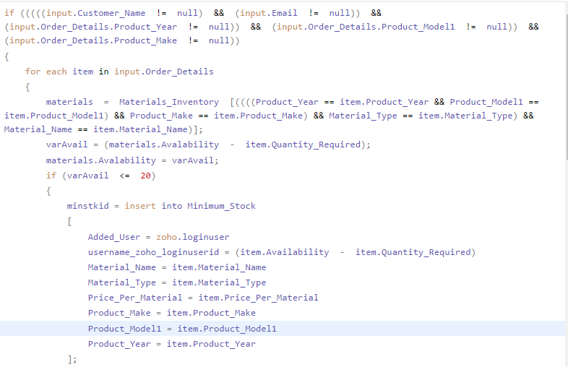

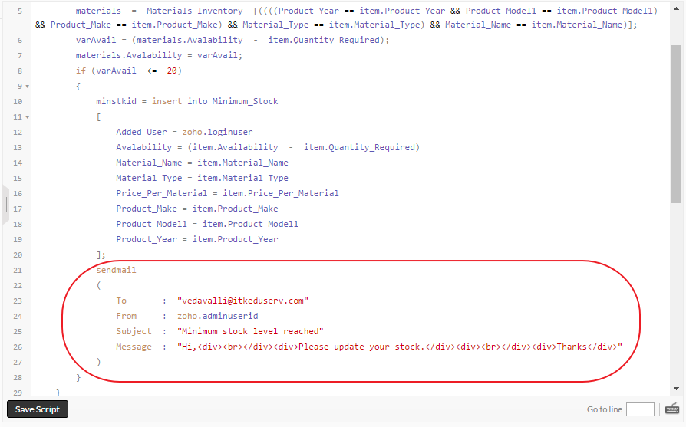

**Lesson 19: Create a Form Warehouse Management**

**Scenario**

The Sales Management app used Check the Customer Details,Product Order Id , Delivery Date and Dispatch Details. We will now create the **Warehouse Management** Form in One Stop Auto Shop Online app.

1. In Form Properties, enter Form Name as **Warehouse Management**. Now, add the following Fields to the Form.

○ Add Single Line Field to enter the Customer Name

▪ From the Fields List, drag and drop a **Single Line** field to the top of the Warehouse Management Form.

▪ On the right side of form editor, on the **Field Properties** Configuration object,for Field Name **Customer Name.**

▪ In the Validation configuration box, check the **Mandatory** check-box.

* Add Number Field to enter the Order Id of the Customer

▪ From the Fields List, drag and drop a **Number** field to the below the Customer Name Field.

▪ On the right side of form editor, on the **Field Properties** Configuration object,for Field Name **Order Id.**

▪ In the Validation configuration box, check the **Mandatory** check-box.

○ Add Contact Number Field to enter the Contact Details of the Customer

▪ From the Fields List, drag and drop a **Single Line** field to the below the Order Id Field.

▪ On the right side of form editor, on the **Field Properties** Configuration object,for Field Name **Customer Contact Number.**

▪ In the Validation configuration box, check the **Mandatory** check-box.

○ Add Email Field to store mail id of the Customer

▪ From the Fields List, drag and drop a **Email** field below the Customer Contact Number.

▪ On the right side of form editor, on the Field Properties Configuration object, for Field Name **Customer** **Email.**

▪ In the Validation configuration box, check the Mandatory check-box.

* Add Address Field to add the address of the customer

▪ From the Fields List, drag and drop a **Multiline** field below the Email field.

▪ On the right side of form editor, on the Field Properties Configuration object, for Field Name **Delivery** **Address.**

▪ In the Validation configuration box, check the Mandatory check-box.

* Add Date Field to store the Delivery Date for order

▪ From the Fields List, drag and drop a **Date** field below the Delivery Address field.

▪ On the right side of form editor, on the Field Properties Configuration object, for Field Name **To be delivered On or Before.**

▪ In the Validation configuration box, check the Mandatory check-box.

* Add Email Field to store the Dispatcher email address

▪ From the Fields List, drag and drop a **Email** field below the To be delivered On or Beforefield.

▪ On the right side of form editor, on the Field Properties Configuration object, for Field Name **Dispatch Officer Email.**

▪ In the Validation configuration box, check the Mandatory check-box.

* Add Drop Down Field to list the Dispatch Details

▪ From the Fields List, drag and drop a **Drop Down** field below the Final Price.

▪ On the right side of form editor, on the Field Properties Configuration object, for Field Name **Dispatch Details.**

* In properties,add choices to status as Dispatched and Not Dispatched.Make a select of Not Dispatched

▪ In the Validation configuration box, check the Mandatory check-box.

2. Verify that the Form looks like the following image

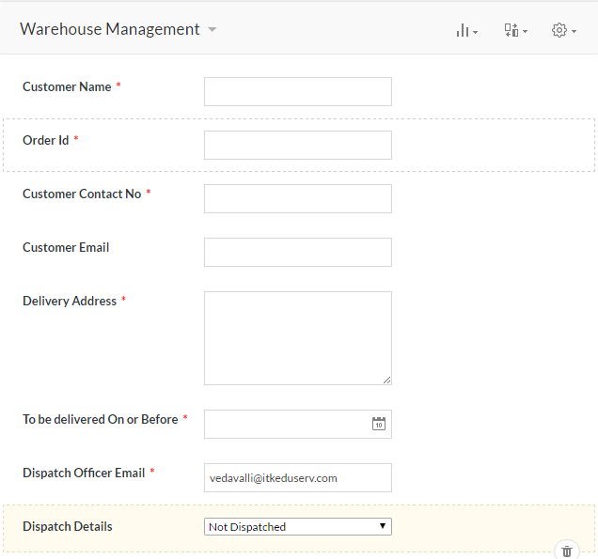

**Lesson 20: Insert records and maintain a Warehouse Management report**

**Scenario**

The Warehouse Form that we have created in the Sales management app enables the Admin to Verify the Order Id,Customer Details and Dispatched Details.we will insert the records in **Warehouse Management** Form through on success action of Place order Form

The steps to automate the workflow are given below.

1. Verify that the **Place Order Form** in the Form Builder

1. Go to the **Field Properties** of sub -form, click **Configure Field Actions.**
2. On the workflow page, you can see that **Form Actions – On Add – On Success** is selected.
3. Drag and drop **if** task from Deluge Task list to the Script Builder area, to write the validating condition.

Write the Code as shown in the below Image

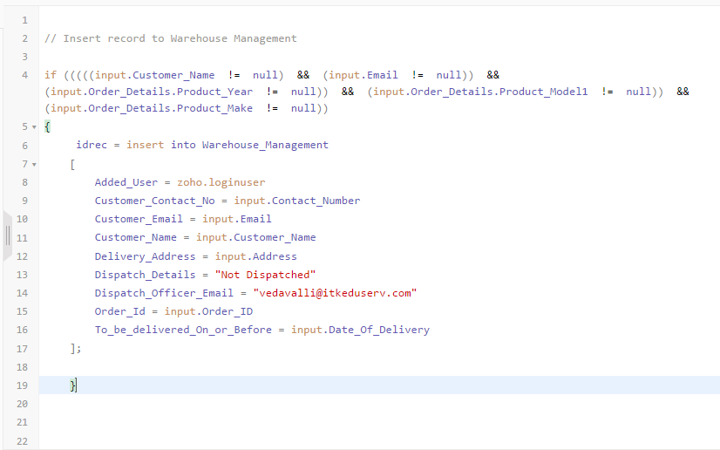

f. At the bottom of the Free-flow scripting window, select **SaveScript**. At the top of

the Free-flow scripting window, verify the status message says **saved.** On the

Zoho Creator menu, select **Access this Application**

**Lesson 21: Insert customer records and maintain a Customer data**

**a.**   **Bidirectional Lookup**

**Scenario :**

The Customer Inquiry and Place order Form that we have created in the Sales management app enables the store the Customer information and customer can order for the product.we will insert the records in **Customer Inquiry** Form through on success action of Place order Form

1. Create the Bi-directional Look

a. Open the Form builder and drag-and-drop the **lookup field** on the **Place Order** Form.

b. A pop up appears that needs you to choose the **Applications – Forms – Fields** to which you want the Material Inventory Form to relate to.

c. Select **Customer Inquiry - Customer Name**.

d. Select the Display type as **Drop-down** so that only one **Customer Inquiry** can be selected from the list.

e. Click on **Done** to save the changes.

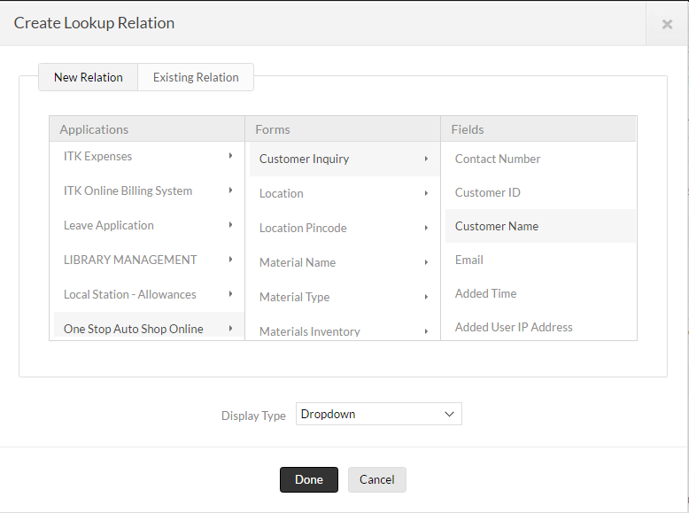

f. For Bi-directional Lookup ,again Go to Customer Inquiry Form add lookup and select the

**Place Order - Customer Inquiry**

g. Select the Display type as **Multi Select** so that Multiple **Place Order** can be selected from the list.

h. Click on **Done** to save the changes.

The steps to automate the workflow are given below.

* Verify that the **Place Order Form** in the Form Builder

* Go to the **Field Properties** of sub -form, click **Configure Field Actions.**
* On the workflow page, you can see that **Form Actions – On Add – On Success** is selected.
* Drag and drop **if** task from Deluge Task list to the Script Builder area, to write the validating condition.

Write the Code as shown in the below Image

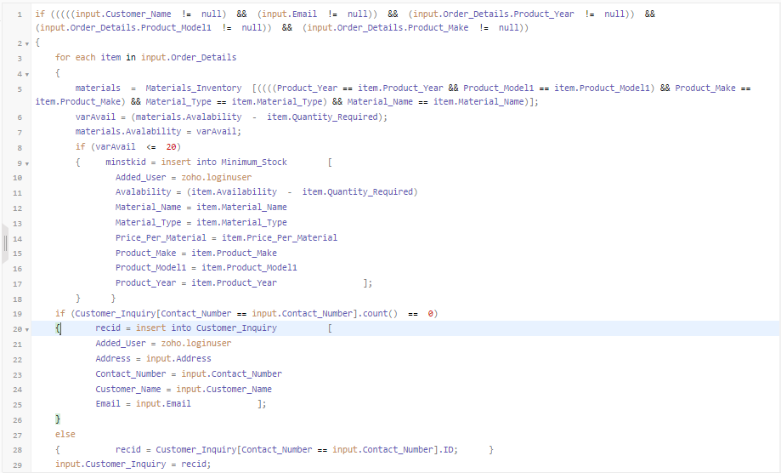

* At the bottom of the Free-flow scripting window, select **SaveScript**. At the top of th

Free-flow scripting window, verify the status message says **saved.** On the Zoho

Creator menu, select **Access this Application**

**Lesson 22: Determine the To be Delivered report**

**Scenario**

The **Sales Management app** is now updated with the Place Order data. Suppose, if we want to display delivery date details in Calendar format, we will create a **Delivery Report**.

1. Create a **Report** On the **Zoho Creator** menu, select **Edit** this application.
2. Select **Create New – Report**.
3. The **New Report – Report Properties** page opens.
4. On the New Report – Report Properties page, for **Report Name**

type **Delivery Report**.

1. For **Report Type** select **Calendar**.
2. For **Report Based** on select **Warehouse Management.**
3. For **Place this Report under** Select **Warehouse Management**.
4. For **Start Date** Select **From Date.**
5. For **End Date** Select **To Date**.
6. **For criteria** select **Select Records**.

Dispatched Details != "Dispatched"

1. Click **Create and Customize**.

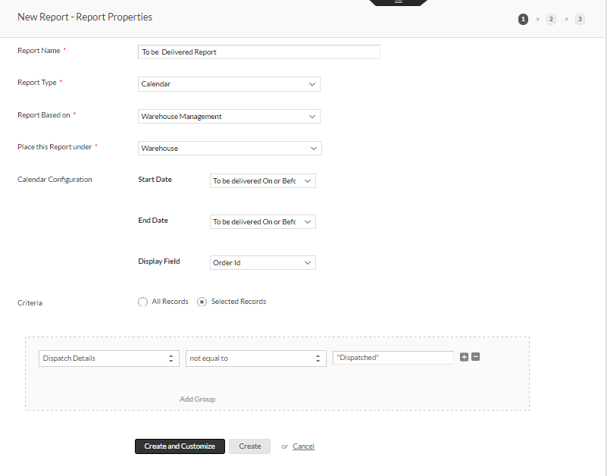

l. At the bottom of the New Report– Report Properties page, select **Create and Customize**.

**Note:** Notice in the upper right portion of the New Report – Column Properties page that the total steps and current steps of the report creation process are noted by circled numbers. The New Report – Column Properties page appears.

m. On the list of **Form fields**, under **Display Name**, click on the **X** next to **Place Order Form** to remove the column from the report.

n. Repeat the previous step to remove if any columns from the report.

o. Verify the columns remaining for the report are **Customer Name,Customer Contact No,Customer Email,Delivery Address,Order ID,Dispatcher Details,Dispatcher Officer Email**.

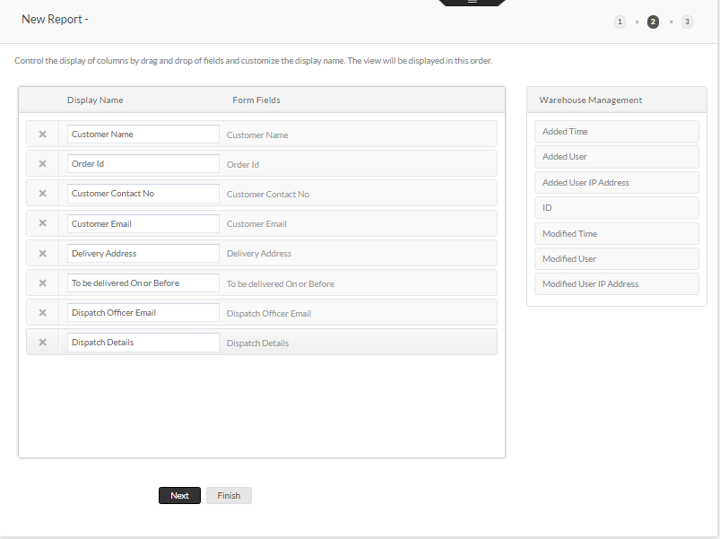

p. Go to Conditional Formating in Report Setting in right corner Click New formatting button.

r. Enter the Formatting Name **datebeforetodaysdate** and select Criteria as Select Record **To be Delivered on or before** condition should be **Before** the **zoho.currentdate**

s.Select formatting option as Event Tilte then select the formatting text and color as red

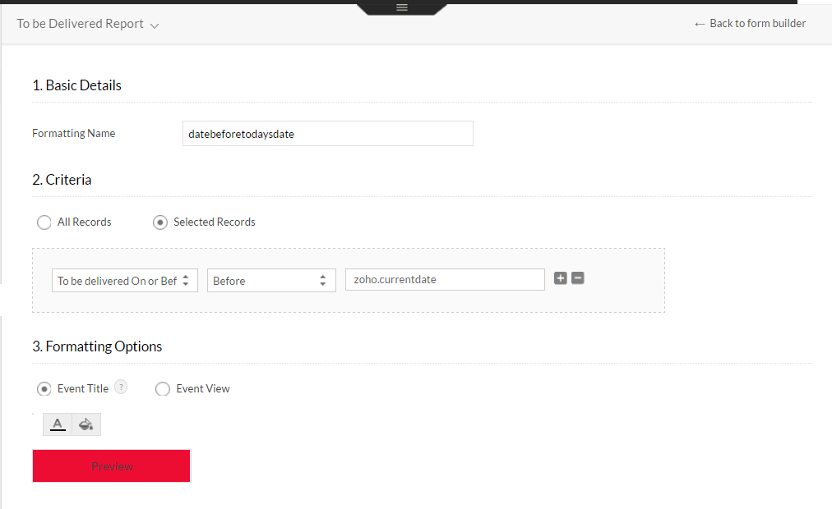

* The image of To be Delivered Report.

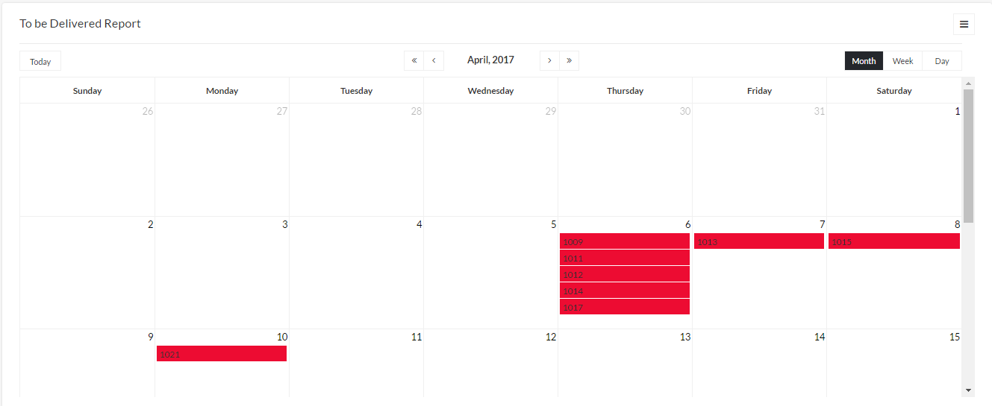

**Lesson 23 :** Function and Create Confirm & Reject button

**Scenario**

What if a customer would like to order for a product? He has to submit **Place Order** Form in **Sales Management** app and will receive a requisition email for the same. In the sales Management app,we will automate the ordering process by giving options to the support staff to either **Confirm** or **Reject**  a order, on click of button.

**1. To create a new Function,**navigate to Report Settings -> Custom Actions and click on

Create one now to create your first function

Now enter the values given in the below Image.

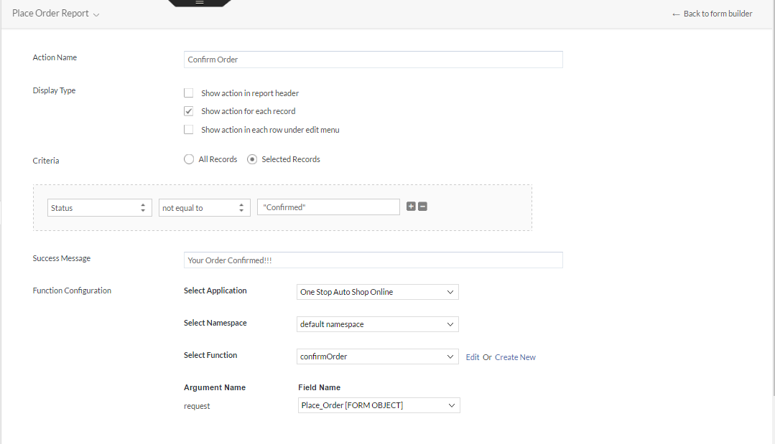

**2.** **Create Function to confirm the order**

* Click on **Workflow– Functions – Add New Function**, to create a new Function.

* In the **Add New Function** Page, specify the function name, namespace, return type and arguments, if any, to be passed to this function.

○ **Function Name:**Name is the identifier by which it will be possible to call the function. Any meaningful name without white space can be specified as function name. The name must not contain any white spaces. Let us specify function name as **ConfirmOrder and RejectOrder**.

○ **Namespace:**Related functions can be grouped under a name based on their purpose, for easy maintenance. Any meaningful name without whitespaces can be specified as namespace.

○ **Return Type:** Return type is the data type specifier of the data returned by the function. If no data is returned by the function, there turn type must be specified as **void**.Let us specify the Return type as **void** as no data will be returned by ConfirmOrder/RejectOrder functions.

○ **Arguments**(as many as needed)**:** They allow passing parameters to the function when it is called. Each argument consists of a data type specifier followed by an identifier, like any regular variable declaration (for example, int a). Select the Form **Place Order Form** as an argument to the function with identifier **request**.

* Click **Done** to create the Function. The function will be added to the Script Builder area as shown below.

* Now we will add the required statement to be executed when the above function is called. The **ConfirmOrder/RejectOrder** functions must update the Status Field in the Place OrderForm with the option“Confirm”/”Reject” and Email notification should be sent to the customer who place a Order. So we will configure the Update Record task with the required value to perform this action.

* Write the below code in **ConfirmOrder** function.

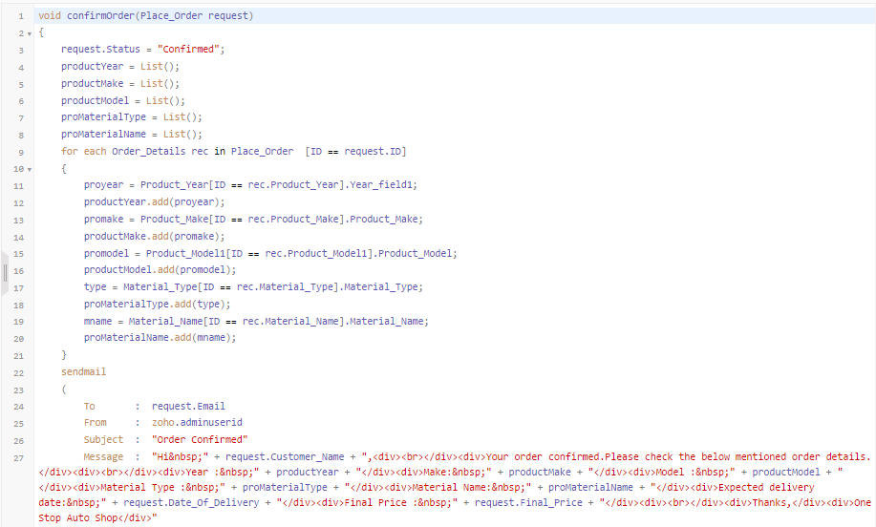

* Write the below code in **OrderNotConfirm** function.

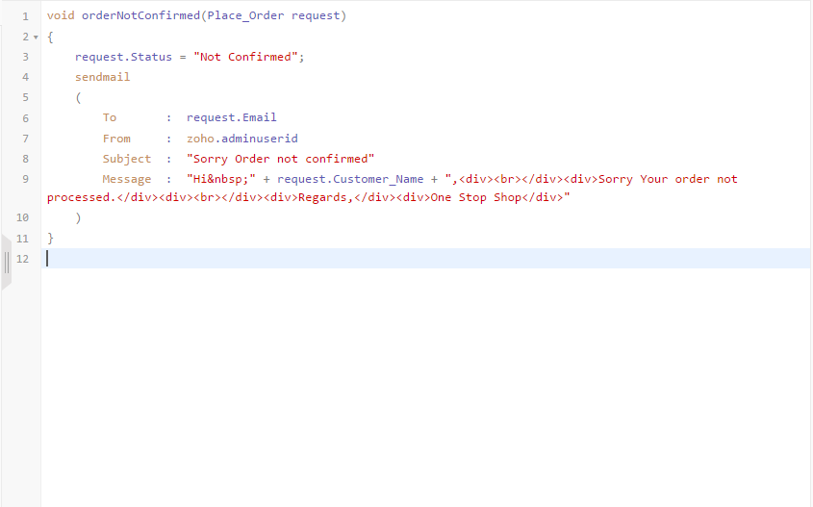

* Click on **SaveScript**.

**3.** **Test the Custom action**

* Access the **Place Order** report in live mode.
* In the screen-shot given below, the Confirm/Reject button is displayed for

each record in the report

* You can either Confirm or Reject using **Confirm/Reject** buttons.

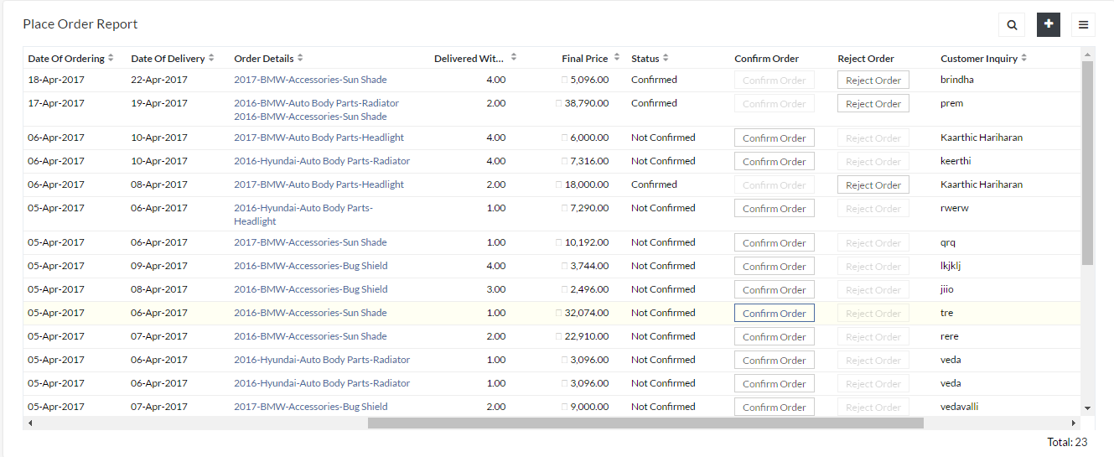

**Lesson 24: Customize the App**

**Scenario**

Zoho Creator, after all, is not just about logic. It also has immense scope for your creative minds. Add a layout and a theme for your Sales Management app to give it a look of your choice.

1. Configure a Themes and Icons Scheme

a. To apply a new theme or an icon,navigate to the live mode of your Application.

b. On the top right, you will see as mall bar split into three sections. Click on the middle section to view various Themes and Icons.

c. Simply select the required Theme and Icon from the available options, which gets applied to your Application automatically.

2. Configure App Sections

a. Under Configure Applications,select **Sections**.

b. Create a New Section and name itas **Reports.**

c. On the sections page, on the right side of the Reports section header box, select **Show /Hide** to hide the Reports section. Notice how the Reports section appearance changes when it’s hidden.

d. Drag the Place Order Report from the Place Order section and drop it in the Reports and check Reports section.

3. Review App Changes

a. In the upper right portion of the app edit user interface, select **Access this application.**

b. Notice that the app is changed with your new theme which you have selected.

c. Verify that there is a new section named Reports and all reports exist in that menu.

**Lesson 25: Schedules**

**Scenario**

The **Sales Management app** is now updated by creating a Schedule.Here we going to create

two types of Schedule Form Schedule and Report Schedule.

1. Form Schedule is based on date and time value present in the

forms.Now we will create a Form Schedule

1. Click on **Workflow -- Schedule -- Form Schedule -- Create**
2. Click on **When to do** enter the title Name as **Dispatch Details Schedule**
3. Select the Form as **Warehouse Management.**
4. click the link select record and select the criteria as,**Dispatch_Details != "Dispatched"**
5. Select the Field **To be delivered On or Before**
6. Select the date and time in **when to do.**
7. Select the **Frequency** should be once

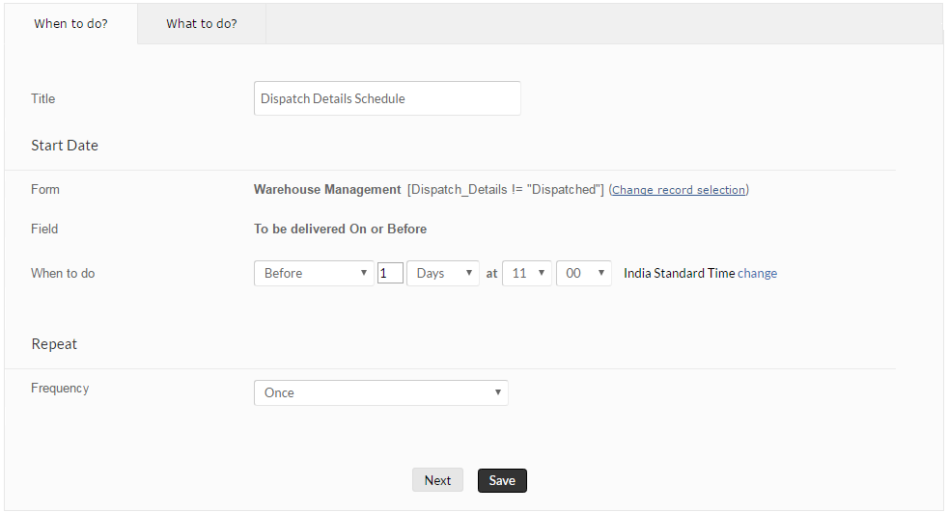

1. click on **Next** button it will go to what to do tab.
2. In **What to Do**, Drag and Drop Send Mail Deluge Task
3. Select the values from given below image

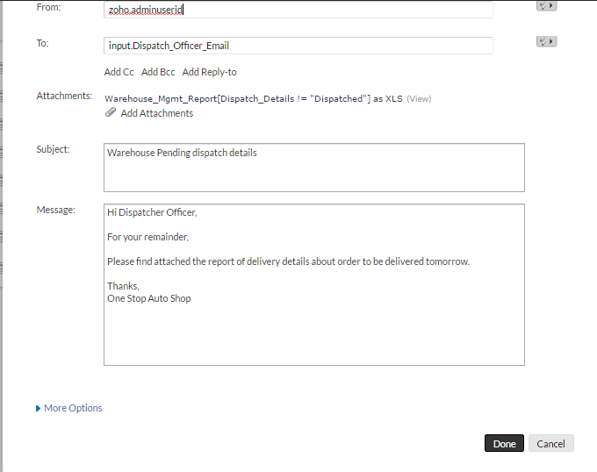



k. Click on Done and click on Save button.

2. Report Schedule is schedule delivered on view data as attachment.Now we will create a Report Schedule

1. Click on **Workflow -- Schedule -- New Schedule -- Report Schedule**
2. Click on **When to do** enter the title Name as **Minimum Stock**
3. Select the Date and Time **.**
4. Select Frequency as **Weekly** and Select Day Of Week **Monday**
5. In What to do Enter the values of To,Subject,Attachments,Message and Click the Save button

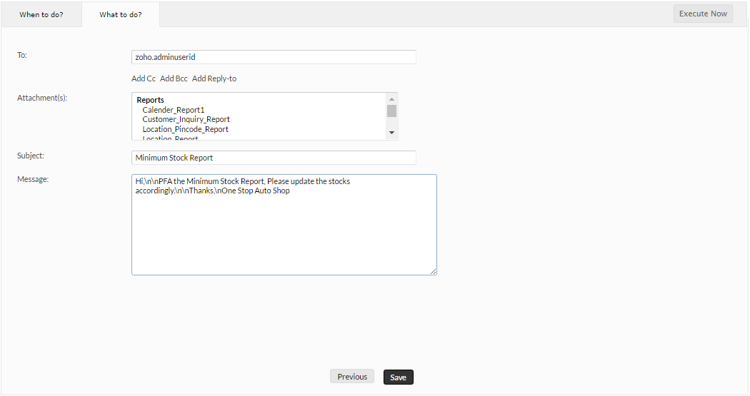

f**.** Click on Execute Now Button in right Corner and verify the mail

**Lesson 26: Create calendar report for Place Order**

**Scenario**

The **Sales Management app** is now updated with the Place Order data. Suppose, if we want to display order details in Calendar format, we will create a **Calendar Report**.

1. Create a **Report**

* On the **Zoho Creator** menu, select **Edit** this application.
* Select **Create New – Report**.
* The **New Report – Report Properties** page opens.
* On the New Report – Report Properties page, for **Report Name** type **Date Of Ordering Dates**.
* For **Report Type** select **Calendar**.
* For **Report Based** on select **Place Order.**
* For **Place this Report under** Select **Warehouse**.
* For **Start Date** Select **Date Of Ordering.**
* For **End Date** Select **Expecting Delivery Date**.
* For **Display Field** select **Order ID**.
* **For criteria** select **All Records**.
* Click **Create and Customize**.

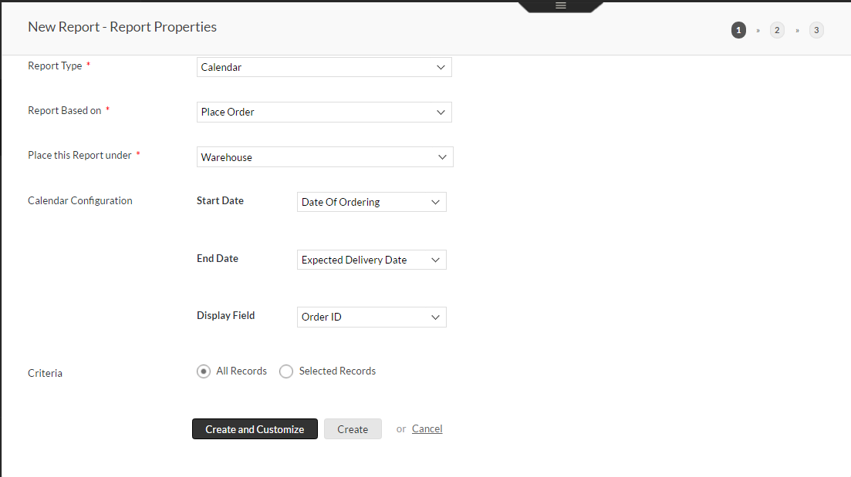

Below Image of Calender Report for Place Order Form

